|  |  |  |  |  |
| --- | --- | --- | --- | --- |
|  |  | | |  |
|  |  | | |  |
|  | 3-Way Splitgate  <<Feature>>  (F004151) | | |  |
|  |  | | |  |
| Document Type | **Feature Document (FD)** | | |  |
| Template Version | **6.1a / FFSD 7.1** | | |  |
| SysML Report Template Version | **O Beta (9/27/2019)** | | |  |
| Document ID | **ffst01.10_featuredocument_sysmlreporttemplate** | | |  |
| Document Location |  | | |  |
| Document Owner | **Rodrigo Celis** | | |  |
| Document Revision | **FD0** | | |  |
| Document Status | **Draft** | | |  |
| Date Issued | **2021/07/28** | | |  |
| Date Revised | **2021/07/28** | | |  |
| Document Classification | GIS1 Item Number: | **27.60/35** | |  |
| GIS2 Classification: | **Confidential** | |
|  | | | | |
|  | | | | |
| Document Approval | | | | |
| Person | Role | | Email Confirmation | Date |
|  |  | |  |  |
|  |  | |  |  |

**Auto-Generated by MagicDraw**

Printed Copies Are Uncontrolled

# Disclaimer

**This document contains Ford Motor Company Confidential information. Disclosure of the information contained in any portion of this document is not permitted without the expressed, written consent of a duly authorized representative of Ford Motor Company, Dearborn, Michigan, U.S.A.**

**Copyright, Ó 2016 Ford Motor Company**

This document contains information developed and accumulated by and for FORD MOTOR COMPANY. As such, it is a proprietary document, which, if disseminated to unauthorized persons, would provide others with restricted information, data, or procedures not otherwise available, exposing the FORD MOTOR COMPANY to potential harm.

Employees and suppliers having custody of this specification or authorized to use it must be cognizant of its proprietary nature and ensure that the information herein is not made available to unauthorized persons.

FORD MOTOR COMPANY reserves the right to protect this work as an unpublished copyrighted work in the event of an inadvertent or deliberate unauthorized publication. FORD MOTOR COMPANY also reserves its rights under copyright laws to protect this work as a published work.

This document or portions thereof shall not be distributed outside FORD MOTOR COMPANY without prior written consent. Refer all questions concerning disclosure to the author(s) or to any duly authorized representative of Ford Motor Company.

# Contents

1.1.2 Decomposition of Functional Safety Requirement 13

Disclaimer 22

Contents 23

2 Introduction 26

2.1 Document Purpose 26

2.2 Document Scope 26

2.3 Document Audience 26

2.3.1 Stakeholder List 26

2.4 Document Organization 26

2.4.1 Document Context 26

2.4.2 Document Structure 27

2.5 Document Conventions 27

2.5.1 Requirements Templates 27

3 Feature Overview 28

3.1 Purpose and Description of Feature 28

3.2 Feature Variants 28

3.2.1 Regions & Markets 29

3.3 Input Requirements 29

3.3.1 Legal Requirements 30

3.3.2 Trustmark Requirements 30

3.3.3 Industry Standards 30

3.3.4 Attribute Requirements 30

3.4 Lessons Learned 30

3.5 Assumptions 31

3.6 References 31

3.6.1 Ford Documents 32

3.6.2 External Documents and Publications 32

3.7 Glossary 33

3.7.1 Parameters / Values 33

4 Feature Context 34

4.1 Feature Context Diagram 34

4.2 List of Influences 34

5 Feature Modeling 36

5.1 Operation Modes and States 36

5.2 Use Cases 38

5.2.1 Use Case Diagram 38

5.2.2 Actors 39

5.2.3 Use Case Descriptions 39

5.3 Driving and Operation Scenarios 43

5.4 Decision Tables 45

6 Feature Requirements 46

6.1 Functional Requirements 46

6.1.1 Error Handling 47

6.2 Non-Functional Requirements 47

6.2.1 Safety 47

6.2.2 Security 47

6.2.3 Reliability 47

6.3 HMI Requirements 47

6.4 Other Requirements 48

6.4.1 Design Requirements 48

6.4.2 Manufacturing Requirements 48

6.4.3 Service Requirements 48

6.4.4 After Sales Requirements 48

6.4.5 Process Requirements 48

6.4.6 Uncategorized Requirements 49

7 Functional Safety 50

7.1 System Behaviors for HARA 50

7.2 Safety Assumptions 50

7.3 Safety Goals 51

7.4 Functional Safety Requirements 53

7.4.1 Safety Goal: 53

7.4.2 Derivation of Functional Safety Requirements on Assumptions 55

7.5 ASIL Decomposition of Functional Safety Requirements 56

8 Architecture 57

8.1 Functional Architecture 57

8.1.1 List of Functions 57

8.2 Logical Architecture 58

8.2.1 Logical Interfaces 59

9 Open Concerns 61

10 Revision History 62

11 Appendix 63

11.1 Definitions 63

11.2 Abbreviations 63

**List of Figures**

Figure 1. 12

Figure 2: 28

Figure 3: - 28

Figure 4: 34

Figure 5: 36

Figure 6: 38

Figure 7:  55

Figure 8: 57

Figure 9: 58

**List of Tables**

Table 1: Features described in this FD 26

Table 2: Feature Variants 29

Table 3: Regions & Markets 29

Table 4: Ford internal Documents 32

Table 5: Ford internal Documents *(not specified in SysML model)* 32

Table 6: External documents and publications 32

Table 7: External documents and publications *(not specified in SysML model)* 33

Table 8: Parameters / Values used in this document *(Not supported by MagicDraw report generation)* 33

Table 9: List of Influences 35

Table 10: Operation Modes and States on 36

Table 11: Transitions between Operation Modes and States on 38

Table 12: List of Actors 39

Table 13: System Behaviors for HARA 50

Table 14: Functional Safety Assumptions 51

Table 15: Functional Safety Goals 53

Table 16: List of Functions 58

Table 17: List of Functions on 58

Table 18: Feature Interactions 59

Table 19: Feature Interactions on 59

Table 20: Open Concerns *(Not supported by MagicDraw report generation)* 61

Table 21: Definitions used in this document 63

Table 22: Abbreviations used in this document 64

# Introduction

## Document Purpose

A Feature Document (FD) document specifies **what** the feature shall do and how it shall behave from customer perspective. It should also provide reasoning and background **why** we have the feature in the vehicle.

The FD also serves as an Item Definition as defined by ISO26262 for those features, which follow the Ford Functional Safety process.

To get more information about the concept of feature, function and component level abstraction refer to the [Ford RE Wiki](http://wiki.ford.com/display/RequirementsEngineering/Requirements+Engineering+for+SW+Enabled+Features). For details on the Ford Functional Safety (ISO26262) process refer to the [Ford Functional Safety Sharepoint](https://pd3.spt.ford.com/sites/GlobalFunctionalSafety/Pages/default.aspx).

## Document Scope

This Feature Document (FD) specifies the following features:

|  |  |  |  |
| --- | --- | --- | --- |
| **Feature ID** | **Feature Name** | **Owner** | **Reference** |
| F004151 | 3-Way Splitgate  (Program(s): 24MY U71x) | Rodrigo Celis |  |

Table 1: Features described in this FD

## Document Audience

The FD is written by the feature owner of Rodrigo Celis. All Stakeholders, i.e., all people who have a valid interest in the feature should read and, if possible, review the FD. It needs to be guaranteed, that all stakeholders have access to the currently valid version of the FD.

### Stakeholder List

For the latest list of stakeholder of the feature and their influence refer to <Put VSEM Link here>.

|  |  |  |  |  |
| --- | --- | --- | --- | --- |
| **Name** | **CDSID** | **Contact Info** | **Role** | **Stakeholder Group** |
| Ali Kabalan | Akabala1 |  | Functional Architecture |  |
| Pooja Muralidas | Pmural11 |  | Rear Fascia |  |
| Kevin Gustafson | kgustafs |  | Underbody Engineer |  |
| Karen Nuler | Knuler1 |  | VO Body |  |
| Jeff Comfort | jcomfort |  | HLM supervisor |  |
| Steven Pisarski | spisarsk |  | Rear Body System Engineer |  |
| John Fransen | jfransen |  | VO Final |  |
| Roderick Villacorta | rvillaco |  | VO Final |  |
| John Kollman | Jkollma4 |  | HLM Rear Latch Engineer |  |
| Alex Long | Along4 |  | Feature Requestor |  |
| Kassandra Nichols | Knicho70 |  | CIED |  |
| William McRoy | wmcroy |  | Liftgate Core Module Engineer |  |
| Sejal Schreffler | sshreffl |  | Vehicle Integration |  |
| Tamika Donaldson | Tdonald9 |  | Liftgate/Tailgate D&R |  |
| MBSE Engineer |  |  |  |  |
| Edward Miller | Emill177 |  | Functional Safety |  |
| Ziad Jbeily | zjbeily |  | Liftgate ECU Applications Engineer |  |
| Rodrigo Celis | Rcelis6 |  | Feature Owner |  |
| Paul Linden | Along4 |  | Design Assurance Engineer |  |
| Dave Diamond | ddiamond |  | Feature Champion |  |
| Marshall Robshaw | Mrobsha1 |  | CIED |  |
| Gonzalo Farfan | gfarfan |  | MBSE Engineer |  |
| Jennifer Pastin | jpastin |  | Body Structure Engineer |  |
| Luis Benavides | Lbenavi3 |  | Rear Fascia |  |
| Spurthi Varma Ganna | Sganna |  | Feature Owner |  |
| Bharath Bahunuthula | bbahunut |  | Functional Safety |  |
| Anthony Ward | Award110 |  | Pre-Feature Owner |  |

## Document Organization

### Document Context

Refer to the [Specification Structure page](http://wiki.ford.com/display/RequirementsEngineering/Specification+templates) in the [Ford RE Wiki](http://wiki.ford.com/display/RequirementsEngineering/Requirements+Engineering+for+SW+Enabled+Features) to understand how the FD relates to other Ford Requirements Documents and Specifications.

### Document Structure

The structure of this document is explained below:

**Section 1** – Introduction how to use this document including responsibilities and requisite documents. Explains the terminology. Gives a clarification of the definitions, concepts and abbreviations used in the document.

**Section 2** – Feature Description. States briefly the background and the purpose of the feature, feature variants and corresponding regions and markets. Also includes input requirements, assumptions and constraints.

**Section 3** – Feature Context describes all external entities, which have an influence on the feature.

**Section 4** – Feature Modeling. Contains Use Case, Driving Scenarios, State Charts to describe the functional behavior of the feature.

**Section 5** – Safety. Lists System Behaviors and Safety Goals of the feature.

**Section 6** – Feature Requirements. Lists functional and non-functional requirements of the feature.

**Section 7** – Architecture. Shows the coarse architecture, which the feature requirements are deployed to. Describes the elements and the boundary of the feature as well as the decomposition and distribution of associated functions.

**Section 8** – List of Open Concerns

**Section 9** – Document Change History including a list of new or modified requirements. The requirements in this document are tagged, and this section contains different types of tables listing all, new, or changed requirements by their title and page no.

**Section 10** – Appendix

## Document Conventions

### Requirements Templates

Each requirement, use case or scenario in this specification shall follow the corresponding template given in the document template *Specification_Macros.dotm* at [RE Wiki - Specification Templates](http://wiki.ford.com/display/RequirementsEngineering/Specification+templates?src=contextnavpagetreemode).

#### Identification of requirements

#### Requirements Attributes

The templates provided by *Specification_Macros.dotm* define a list of attributes for each requirement. This helps to classify the requirement. The attributes are explained at [RE Wiki - Requirements Attributes](http://wiki.ford.com/display/RequirementsEngineering/Requirements+Attributes?src=contextnavpagetreemode).

## References

### Ford Documents

List here all Ford internal documents, which are directly related to the feature.

| **Reference** | **Title** | **Doc. ID** | **Document Location** | **Revision** |
| --- | --- | --- | --- | --- |
| Ford GIS Standard | Ford GIS Standard |  |  |  |

Table 4: Ford internal Documents

### External Documents and Publications

The list of external documents could include books, reports and online sources.

| **Reference** | **Document / Publication** | **Document Location** |
| --- | --- | --- |
| IEEE Std 1012-2004 IEEE Standard for Software Verification and Validation |  |  |
| ISO/IEC 19500-2:2003 | Information technology -- Open Distributed Processing -- Part 2 |  |
| UML Testing Profile (UTP), v1.2 |  |  |
| Wikipedia |  |  |

Table 6: External documents and publications

## Glossary

See Appendix for Definitions and Abbreviations.

### Parameters / Values

| **Name** | **Description** | **Range / Resolution** |
| --- | --- | --- |

Table 8: Parameters / Values used in this document

# Feature Overview

## Purpose and Description of Feature

The split liftgate opens by flipping up the top ¾ portion providing a physical barrier to prevent items from falling out the back. The lower section can then rotate down to provide a tailgate like a truck and a surface to slide large items in and out.

The 3-Way Liftgate provides flexibility around how cargo is managed and turns the rear of the vehicle into a hub for bonding with family and friends. This dual benefit resonates highly with our Heroic Pioneer customer.

Two variants of the splitgate will exist. One variant will have the upper door fully motorized and the lower door fully motorized allowing full automatic control of the splitgate, as well as manual control if desired. The other variant has the upper door fully motorized and the lower door not motorized. The lower door will have electrically controlled latches but no motor, so will need to be manually moved to the desired position. The Lincoln Navigator will be 100% the first variant, fully automatic, and the Ford Expedition will have a 50%-50% take rate for the two variants.

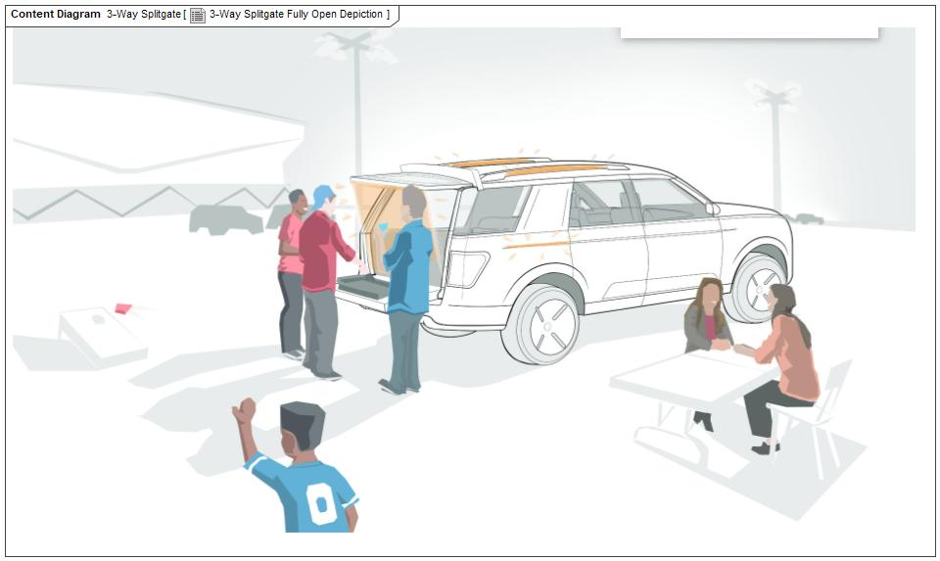

Figure 2: 3-Way Splitgate Fully Open Depiction

## Feature Variants

|  |  |  |
| --- | --- | --- |
| **Variant Name** | **Variant Description** | **Remarks** |
| **Powered Lower Splitgate** | This variant will have the upper door fully motorized and the lower door fully motorized allowing full automatic control of the splitgate, as well as manual control if desired. |  |
| **Unpowered Lower Splitgate** | This variant will have the upper door fully motorized and the lower door not motorized. The lower door will have electrically controlled latches but no motor, so will need to be manually moved to the desired position. |  |

Table 2: Feature Variants

### Regions & Markets

|  |  |  |  |  |  |  |
| --- | --- | --- | --- | --- | --- | --- |
| **Market /**  **Region**  Variant Name | **North America** | **South America** | **Europe** | **Middle East/Africa** | **Asia / Pacific** | **China** |
| **Powered Lower Splitgate** | Mandatory | Mandatory | No | Mandatory | Mandatory | Mandatory |
| **Unpowered Lower Splitgate** | Mandatory | Mandatory | No | Mandatory | Mandatory | Mandatory |

Table 3: Regions & Markets

## Input Requirements

### Legal Requirements

* : Compliance with FMVSS101
  + The Feature shall comply with FMVSS101.

### Trustmark Requirements

No Trustmark Requirements specified.

### Industry Standards

* : ISO 26262
  + The system should be developed according to Ford's implementation of Functional Safety.

### Attribute Requirements

#### Proj-AR:14 : Example AR

* + **Rationale:**

## Lessons Learned

No lessons learned specified.

## Assumptions

No Assumptions specified.

# Feature Context

## Feature Context Diagram

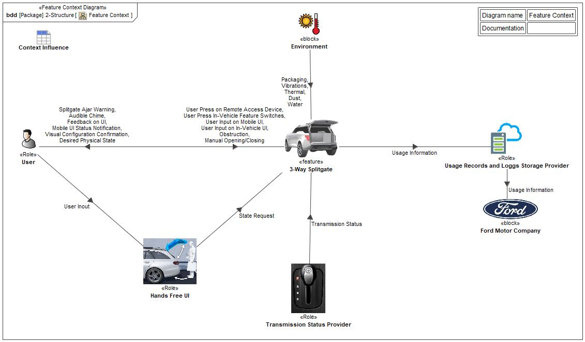

Figure 4: Feature Context

## List of Influences

|  |  |  |
| --- | --- | --- |
| **ID** | **External Entity** | **Influence Description** |
| Audible Chime | 3-Way Splitgate To User | System influence to the user, to let know about the Splitgate status |
| Desired Physical State | 3-Way Splitgate To User | User influence to the System, to provide a desired status of the Splitgate |
| Dust | Environment To 3-Way Splitgate | Environmental influence, may interfere with desired position of the Splitgate |
| Feedback on UI | 3-Way Splitgate To User | System influence to the user |
| Manual Opening/Closing | User To 3-Way Splitgate | User influence to the System |
| Mobile UI Status Notification | 3-Way Splitgate To User | Cloud influence, to provide information to the user via Mobile UI |
| Obstruction | User To 3-Way Splitgate | Environmental influence, may interfere with desired position of the Splitgate |
| Packaging | Environment To 3-Way Splitgate | Environmental influence, may interfere with desired position of the Splitgate |
| Splitgate Ajar Warning | 3-Way Splitgate To User | System influence to the user, to let know about the Splitgate status |
| State Request | Hands Free UI To 3-Way Splitgate | System influence to the user, to let know about the Splitgate status |
| Thermal | Environment To 3-Way Splitgate | Environmental influence, may interfere with desired position of the Splitgate |
| Transmission Status | Transmission Status Provider To 3-Way Splitgate | User influence to the System |
| Usage Information | 3-Way Splitgate To Usage Records and Loggs Storage Provider | User influence to the System |
| Usage Records and Loggs Storage Provider To Ford Motor Company | User influence to the System |
| User Inout | User To Hands Free UI | User influence to the System |
| User Input on In-Vehicle UI | User To 3-Way Splitgate | User influence to the System |
| User Input on Mobile UI | User To 3-Way Splitgate | User influence to the System |
| User Press In-Vehicle Feature Switches | User To 3-Way Splitgate | User influence to the System |
| User Press on Remote Access Device | User To 3-Way Splitgate | User influence to the System |
| Vibrations | Environment To 3-Way Splitgate | Environmental influence, may interfere with desired position of the Splitgate |
| Visual Configuration Confirmation | 3-Way Splitgate To User | Influence Description from Documentation field. |
| Water | Environment To 3-Way Splitgate | Environmental influence, may interfere with desired position of the Splitgate |

Table 9: List of Influences

# Feature Modeling

## Operation Modes and States

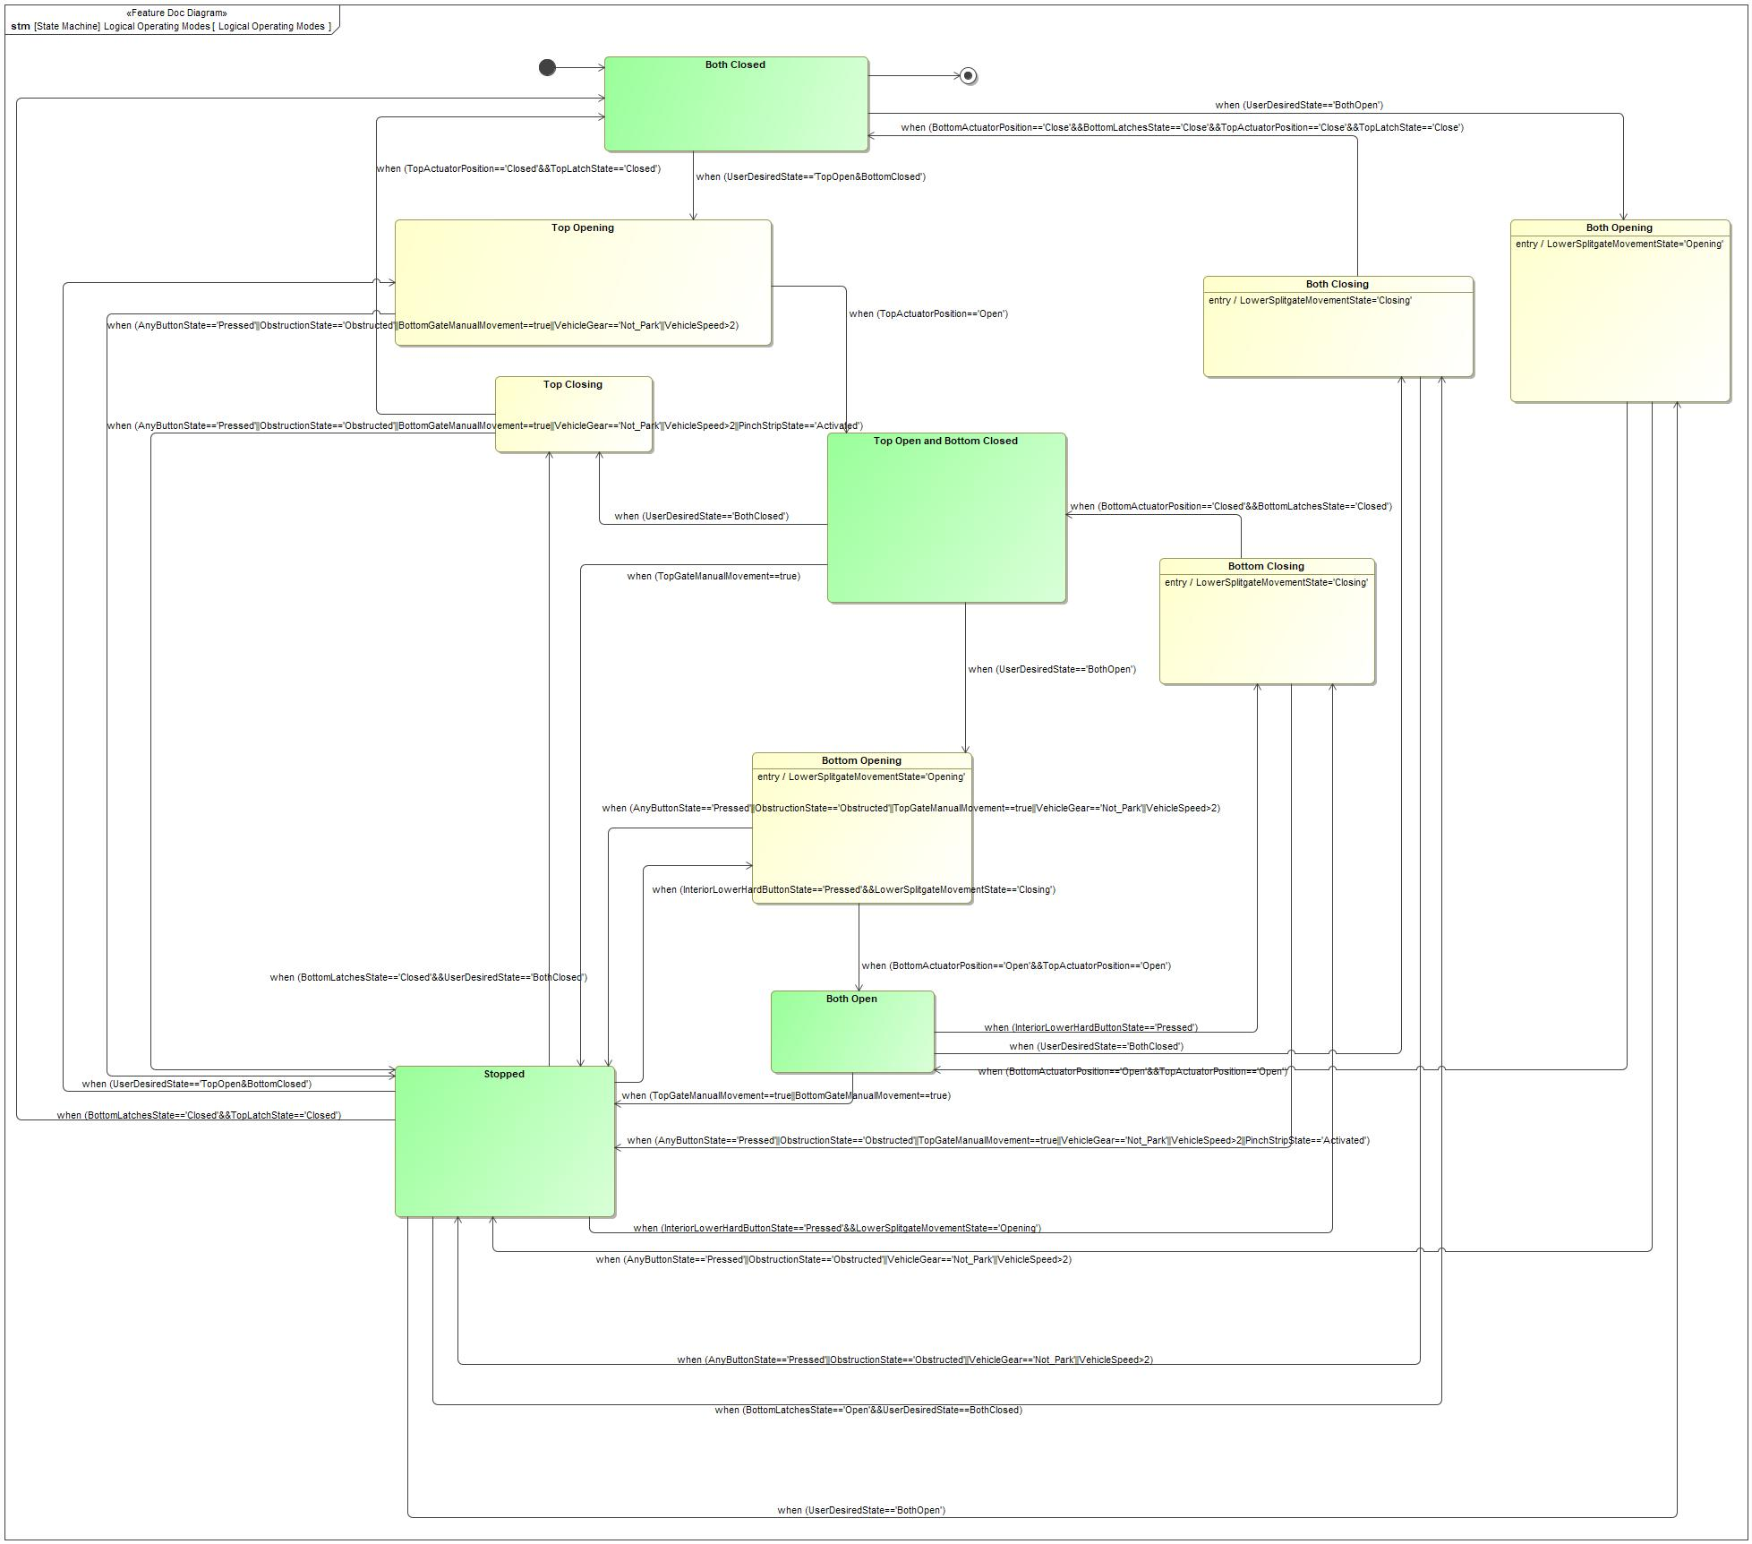

Figure 5: Logical Operating Modes

|  |  |  |
| --- | --- | --- |
| **State** | **Description** | **Requirements Reference** (optional) |
| Both Closed | Doors are closed and cannot be open without explicit user request via HMI control |  |
| Both Closing | Doors are power closing |  |
| Both Open | Doors are opened and cannot be close without explicit user request via HMI control |  |
| Both Opening | Doors are power opening |  |
| Bottom Closing | Tailgate is power closing |  |
| Bottom Opening | Tailgate is power opening |  |
| Stopped | Any gate in power open or power close condition can be stop retaining gate movement and/or pressing any user HMI input |  |
| Top Closing | Liftgate is power closing |  |
| Top Open and Bottom Closed | Liftgate have end power open condition and stop opening and Tailgate remain closed |  |
| Top Opening | Liftgate is power opening |  |

Table 10: Operation Modes and States on Logical Operating Modes

|  |  |  |  |  |
| --- | --- | --- | --- | --- |
| **Transition ID** | **Source** | **Destination** | **Description** | **Requirements Reference**  (optional) |
| T1 | Top Opening | Top Open and Bottom Closed | ChangeEvent when (TopActuatorPosition=='Open') |  |
| T2 | Stopped | Top Closing | ChangeEvent when (BottomLatchesState=='Closed'&&UserDesiredState=='BothClosed') |  |
| T3 | Both Open | Both Closing | ChangeEvent when (UserDesiredState=='BothClosed') |  |
| T4 | Top Open and Bottom Closed | Top Closing | ChangeEvent when (UserDesiredState=='BothClosed') |  |
| T5 | Both Open | Bottom Closing | ChangeEvent when (InteriorLowerHardButtonState=='Pressed') |  |
| T6 | Stopped | Top Opening | ChangeEvent when (UserDesiredState=='TopOpen&BottomClosed') |  |
| T7 | Bottom Opening | Stopped | ChangeEvent when (AnyButtonState=='Pressed'||ObstructionState=='Obstructed'||TopGateManualMovement==true||VehicleGear=='Not_Park'||VehicleSpeed>2) |  |
| T8 | Stopped | Both Closing | ChangeEvent when (BottomLatchesState=='Open'&&UserDesiredState==BothClosed) |  |
| T9 | Both Opening | Stopped | ChangeEvent when (AnyButtonState=='Pressed'||ObstructionState=='Obstructed'||VehicleGear=='Not_Park'||VehicleSpeed>2) |  |
| T10 | Top Closing | Both Closed | ChangeEvent when (TopActuatorPosition=='Closed'&&TopLatchState=='Closed') |  |
| T11 | Stopped | Bottom Opening | ChangeEvent when (InteriorLowerHardButtonState=='Pressed'&&LowerSplitgateMovementState=='Closing') |  |
| T12 | Both Open | Stopped | ChangeEvent when (TopGateManualMovement==true||BottomGateManualMovement==true) |  |
| T13 | Bottom Opening | Both Open | ChangeEvent when (BottomActuatorPosition=='Open'&&TopActuatorPosition=='Open') |  |
| T14 | Top Open and Bottom Closed | Stopped | Name: when (TopGateManualMovement==true))  ChangeEvent when (TopGateManualMovement==true) |  |
| T15 | Both Closed | Top Opening | ChangeEvent when (UserDesiredState=='TopOpen&BottomClosed') |  |
| T16 | Bottom Closing | Stopped | ChangeEvent when (AnyButtonState=='Pressed'||ObstructionState=='Obstructed'||TopGateManualMovement==true||VehicleGear=='Not_Park'||VehicleSpeed>2||PinchStripState=='Activated') |  |
| T17 | Both Opening | Both Open | ChangeEvent when (BottomActuatorPosition=='Open'&&TopActuatorPosition=='Open') |  |
| T18 | Bottom Closing | Top Open and Bottom Closed | ChangeEvent when (BottomActuatorPosition=='Closed'&&BottomLatchesState=='Closed') |  |
| T19 | Both Closing | Stopped | ChangeEvent when (AnyButtonState=='Pressed'||ObstructionState=='Obstructed'||VehicleGear=='Not_Park'||VehicleSpeed>2) |  |
| T20 | Stopped | Both Closed | Name: when  ChangeEvent when (BottomLatchesState=='Closed'&&TopLatchState=='Closed') |  |
| T21 | Both Closed | Both Opening | ChangeEvent when (UserDesiredState=='BothOpen') |  |
| T22 | Top Opening | Stopped | ChangeEvent when (AnyButtonState=='Pressed'||ObstructionState=='Obstructed'||BottomGateManualMovement==true||VehicleGear=='Not_Park'||VehicleSpeed>2) |  |
| T23 | Top Open and Bottom Closed | Bottom Opening | ChangeEvent when (UserDesiredState=='BothOpen') |  |
| T24 | Stopped | Bottom Closing | ChangeEvent when (InteriorLowerHardButtonState=='Pressed'&&LowerSplitgateMovementState=='Opening') |  |
| T25 | Both Closed | a |  |  |
| T26 | Stopped | Both Opening | ChangeEvent when (UserDesiredState=='BothOpen') |  |
| T27 |  |  |  |  |
| T28 | Both Closing | Both Closed | ChangeEvent when (BottomActuatorPosition=='Close'&&BottomLatchesState=='Close'&&TopActuatorPosition=='Close'&&TopLatchState=='Close') |  |
| T29 | Top Closing | Stopped | ChangeEvent when (AnyButtonState=='Pressed'||ObstructionState=='Obstructed'||BottomGateManualMovement==true||VehicleGear=='Not_Park'||VehicleSpeed>2||PinchStripState=='Activated') |  |

Table 11: Transitions between Operation Modes and States on Logical Operating Modes

## Use Cases

### Use Case Diagram

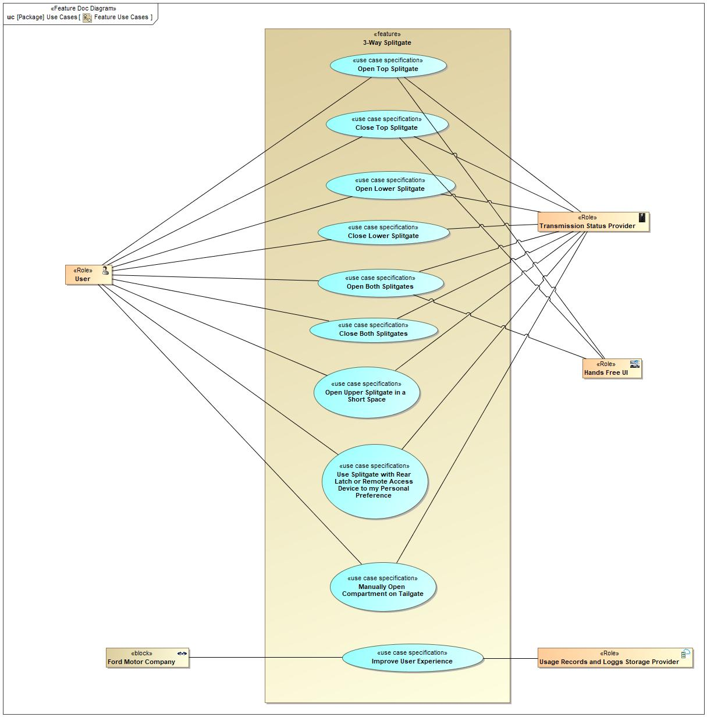

Figure 6: Feature Use Cases

### Actors

| **Actor** | **Description** |
| --- | --- |
| Ford Motor Company |  |
| Hands Free UI | Responsible for allowing the user to use the system without direct touch |
| Transmission Status Provider | Responsible system for providing current status of the Vehicle Transmission |
| Usage Records and Loggs Storage Provider | Usage Records and Logs Storage information will be managed on Cloud |
| User | Main user of the system, this entity will provide the desired state of the Splitgate |

Table 12: List of Actors

### Use Case Descriptions

UC01 Open Top Splitgate

|  |  |  |
| --- | --- | --- |
| **Actors** | Primary | User |
| Secondary | IP Hard Button |
| Secondary | Chime |
| Secondary | Remote Access Device |
| Secondary | Mobile UI |
| Secondary | In-Vehicle UI |
| Secondary | Transmission Status Provider |
| **Subject** |  | 3-Way Splitgate |
| **Description** |  |  |
| **Preconditions** | PreC1 | Both splitgates are closed |
| PreC2 | Rear latch and Remote Access Device are configured to control top splitgate only |
| PreC3 | Transmission status is in park |
| **Main Flow Description** |  | This is the main success scenario |
| **Main Flow** | M1 | User presses the rear latch button located on the outside of the top splitgate |
| M2 | Top splitgate power starts opening |
| M3 | Inactive chime during opening |
| M4 | Top splitgate power opens |
| **Alternative Flow Description** |  | M1 There are different available Splitgate feature UI's for opening the top splitgate |
| **Alternative Flow Steps** | A1 | M1 User presses the Splitgate button located on the Remote Access Device |
| A2 | M1 User presses the Splitgate open/close HMI button on the a screen within the In-Vehicle UI |
| A3 | M1 User presses the Splitgate open/close IP button on the driver side |
| A4 | M1 User presses the Splitgate open/close HMI button on the Mobile UI |
| **Exceptional Flow Description** |  | Continious after M4 |
| **Exceptional Flow Steps** | E1 | Transmission status goes out of park gear while top splitgate is open |
| E2 | Audible chime chimes |
| E3 | A warning screen saying the splitgate is ajar pops up |
| **Postconditions** | PostC1 | Air flows through opened upper splitgate |
| PostC2 | Cargo in trunk can be accessed |
| PostC3 | Items can be packed high in trunk while the closed lower splitgate prevents items from falling out |
| PostC4 | Items in trunk are now reachable while the closed lower splitgate prevents items from falling out |
| PostC5 | Long item can be stably packed out the upper splitgate |
| PostC6 | Upper splitgate glass interior is now reachable to clean from the rear of the vehicle |
| PostC7 | Upper splitgate is opened while not colliding with object behind vehicle due to the short length of the splitgate |

UC02 Open Both Splitgates

|  |  |  |
| --- | --- | --- |
| **Actors** | Primary | User |
| Secondary | IP Hard Button |
| Secondary | Chime |
| Secondary | Remote Access Device |
| Secondary | Mobile UI |
| Secondary | In-Vehicle UI |
| Secondary | Transmission Status Provider |
| Secondary | Hands Free UI |
| **Subject** |  | 3-Way Splitgate |
| **Description** |  |  |
| **Preconditions** | PreC1 | Both splitgates are closed |
| PreC2 | Rear latch and Remote Access Device are configured to control both splitgates |
| PreC3 | Transmission status is in park |
| **Main Flow Description** |  | This is the main success scenario |
| **Main Flow** | M1 | User presses the rear latch button located on the outside of the top splitgate |
| M2 | Both splitgates power start opening |
| M3 | Inactive chime during opening |
| M4 | Both splitgates power open |
| **Alternative Flow Description** |  | M1 There are different available Splitgate feature UI's for opening both splitgates |
| **Alternative Flow Steps** | A1 | M1 User presses the Splitgate button located on the Remote Access Device |
| A2 | M1 User presses the Splitgate open/close HMI button on the a screen within the In-Vehicle UI |
| A3 | M1 User presses the Splitgate open/close IP button on the driver side |
| A4 | M1 User presses the Splitgate open/close HMI button on the Mobile UI |
| A5 | M1 User kicks foot underneath bumper |
| **Exceptional Flow Description** |  | Continious after M4 |
| **Exceptional Flow Steps** | E1 | Transmission status goes out of park gear while top splitgate is open |
| E2 | Audible chime chimes |
| E3 | A warning screen saying the splitgate is ajar pops up |
| **Postconditions** | PostC1 | Both splitgates are opened while not colliding with object behind vehicle due to the short length of the splitgates |
| PostC2 | Cargo in trunk can be accessed |
| PostC3 | Lower splitgate is at good height, strength, and comfort level to sit two people or 300 pounds on without breaking |
| PostC4 | Lower splitgate is flat and stable enough to serve as a table |
| PostC5 | User can manually clip tent sides to clips located on the edges of the splitgate |

UC03 Close Top Splitgate

|  |  |  |
| --- | --- | --- |
| **Actors** | Primary | User |
| Secondary | IP Hard Button |
| Secondary | Chime |
| Secondary | Remote Access Device |
| Secondary | Mobile UI |
| Secondary | In-Vehicle UI |
| **Subject** |  | 3-Way Splitgate |
| **Description** |  |  |
| **Preconditions** | PreC1 | Lower splitgate is shut |
| PreC2 | Upper splitgate is opened |
| **Main Flow Description** |  | This is the main success scenario |
| **Main Flow** | M1 | User presses the button located on the interior of the upper splitgate |
| M2 | Top splitgate power starts closing |
| M3 | Chime sounds during closing |
| M4 | Top splitgate power closes |
| **Alternative Flow Description** |  | M1-M4 This alternative flow replaces M1 to M4 |
| **Alternative Flow Description** |  | M1 There are different available Splitgate feature UI's for closing the top splitgate |
| **Alternative Flow Steps** | A1 | M1-M4 User manually shuts the opened top splitgate |
| A2 | M1 User presses the Splitgate button located on the Remote Access Device |
| A3 | M1 User presses the Splitgate open/close HMI button on the a screen within the In-Vehicle UI |
| A4 | M1 User presses the Splitgate open/close IP button on the driver side |
| A5 | M1 User presses the Splitgate open/close HMI button on the Mobile UI |
| **Postconditions** | PostC1 | Splitgate is fully closed |

UC04 Close Both Splitgates

|  |  |  |
| --- | --- | --- |
| **Actors** | Primary | User |
| Secondary | IP Hard Button |
| Secondary | Chime |
| Secondary | Remote Access Device |
| Secondary | Mobile UI |
| Secondary | In-Vehicle UI |
| **Subject** |  | 3-Way Splitgate |
| **Description** |  |  |
| **Preconditions** | PreC1 | Both splitgates are opened |
| **Main Flow Description** |  | This is the main success scenario |
| **Main Flow** | M1 | User presses the button located on the interior of the upper splitgate |
| M2 | Both splitgates power start closing |
| M3 | Chime sounds during closing |
| M4 | Both splitgates power close |
| **Alternative Flow Description** |  | M1 There are different available Splitgate feature UI's for closing both splitgates |
| **Alternative Flow Steps** | A1 | M1 User presses the Splitgate button located on the Remote Access Device |
| A2 | M1 User presses the Splitgate open/close HMI button on the a screen within the In-Vehicle UI |
| A3 | M1 User presses the Splitgate open/close IP button on the driver side |
| A4 | M1 User presses the Splitgate open/close HMI button on the Mobile UI |
| **Postconditions** | PostC1 | Splitgate is fully closed |

UC05 Open Lower Splitgate

|  |  |  |
| --- | --- | --- |
| **Actors** | Primary | User |
| Secondary | IP Hard Button |
| Secondary | Chime |
| Secondary | Mobile UI |
| Secondary | In-Vehicle UI |
| Secondary | Transmission Status Provider |
| **Subject** |  | 3-Way Splitgate |
| **Description** |  |  |
| **Preconditions** | PreC1 | Lower splitgate is shut |
| PreC2 | Upper splitgate is opened |
| **Main Flow Description** |  | This is the main success scenario |
| **Main Flow** | M1 | User presses the button located on the interior of the lower splitgate |
| M2 | Lower splitate power starts opening |
| M3 | Inactive chime during opening |
| M4 | Lower splitgate opens |
| **Alternative Flow Description** |  | M1 There are different available Splitgate feature UI's for opening lower splitgate |
| **Alternative Flow Steps** | A1 | M1 User presses the Splitgate open/close HMI button on the a screen within the In-Vehicle UI |
| A2 | M1 User presses the Splitgate open/close IP button on the driver side |
| A3 | M1 User presses the Splitgate open/close HMI button on the Mobile UI |
| **Exceptional Flow Description** |  | Continious after M4 |
| **Exceptional Flow Steps** | E1 | Transmission status goes out of park gear while top splitgate is open |
| E2 | Audible chime chimes |
| E3 | A warning screen saying the splitgate is ajar pops up |
| **Postconditions** | PostC1 | Both splitgates are opened while not colliding with object behind vehicle due to the short length of the splitgates |
| PostC2 | Lower splitgate is at good height, strength, and comfort level to sit two people or 300 pounds on without breaking |
| PostC3 | Lower splitgate is flat and stable enough to serve as a table |
| PostC4 | User can manually clip tent sides to clips located on the edges of the splitgate |

UC06 Close Lower Splitgate

|  |  |  |
| --- | --- | --- |
| **Actors** | Primary | User |
| Secondary | IP Hard Button |
| Secondary | Chime |
| Secondary | Mobile UI |
| Secondary | In-Vehicle UI |
| Secondary | Transmission Status Provider |
| **Subject** |  | 3-Way Splitgate |
| **Description** |  |  |
| **Preconditions** | PreC1 | Both splitgates are opened |
| **Main Flow Description** |  | This is the main success scenario |
| **Main Flow** | M1 | User presses the button located on the interior of the lower splitgate |
| M2 | Lower splitgate power starts closing |
| M3 | Chime sounds during closing |
| M4 | Lower splitgate closes |
| **Alternative Flow Description** |  | M1-M4 This alternative flow replaces M1 to M4 |
| **Alternative Flow Description** |  | PreM1 This alternative flow may happen before M1 |
| **Alternative Flow Description** |  | M1 There are different available Splitgate feature UI's for closing the top splitgate |
| **Alternative Flow Steps** | A1 | M1-M3 User manually shuts the opened lower splitgate |
| A2 | PreM1 User stows long item in back |
| A3 | M1 User presses the Splitgate open/close HMI button on the a screen within the In-Vehicle UI |
| A4 | M1 User presses the Splitgate open/close IP button on the driver side |
| A5 | M1 User presses the Splitgate open/close HMI button on the Mobile UI |
| **Exceptional Flow Description** |  | Continious after M4 |
| **Exceptional Flow Steps** | E1 | Transmission status goes out of park gear while top splitgate is open |
| E2 | Audible chime chimes |
| E3 | A warning screen saying the splitgate is ajar pops up |
| **Postconditions** | PostC1 | Items can be packed high in trunk while the closed lower splitgate prevents items from falling out |
| PostC2 | Items in trunk are now reachable while the closed lower splitgate prevents items from falling out |
| PostC3 | Long item can be stably packed out the upper splitgate |

UC07 Use Splitgate with Rear Latch or Remote Access Device to my Personal Preference

|  |  |  |
| --- | --- | --- |
| **Actors** | Primary | User |
| Secondary | In-Vehicle UI |
| **Subject** |  | 3-Way Splitgate |
| **Description** |  |  |
| **Preconditions** | PreC1 | Vehicle is configured for 3-Way Splitgate feature |
| **Main Flow Description** |  | This is the main success scenario |
| **Main Flow** | M1 | User/Dealer navigates to splitgate input configuration page in In-Vehicle UI |
| M2 | User selects the desired response to keyfob button presses and rear latch presses, either top splitgate or both splitgates open |
| M3 | In-Vehicle UI page confirms that settings have been changed |
| **Postconditions** | PostC1 | Next time that a user presses keyfob splitgate button or rear latch button, splitgate will respond according to the configured setting |

UC08 Improve User Experience

|  |  |  |
| --- | --- | --- |
| **Actors** | Primary | Ford Motor Company |
| Secondary | Usage Records and Loggs Storage Provider |
| **Subject** |  | 3-Way Splitgate |
| **Description** |  |  |
| **Preconditions** | PreC1 | Vehicle is configured for 3-Way Splitgate feature |
| **Main Flow Description** |  | This is the main success scenario |
| **Main Flow** | M1 | 3-Way Splitgate generates relevant feature use data |
| M2 | The Usage Records and Loggs Storage Provider stores relevant feature use data |
| **Postconditions** | PostC1 | Data on splitgate usage is available for Ford Motor Company to improve user experience in future |

UC09 Manually Open Compartment on Tailgate

|  |  |  |
| --- | --- | --- |
| **Actors** | Primary | User |
| Secondary |  |
| **Subject** |  | 3-Way Splitgate |
| **Description** |  |  |
| **Preconditions** | PreC1 | Both splitgates are open |
| **Main Flow Description** |  | This is the main success scenario |
| **Main Flow** | M1 | User manually opens compartment located on lower splitgate interior |
| **Postconditions** | PostC1 | Compartment cover open position can be used as an extended table for tailgating |
| PostC2 | Storage area in compartment allows storage and access to small items for tailgating |

UC10 Open Upper Splitgate in a Short Space

|  |  |  |
| --- | --- | --- |
| **Actors** | Primary | User |
| Secondary |  |
| **Subject** |  | 3-Way Splitgate |
| **Description** |  |  |
| **Preconditions** | PreC1 | Vehicle is configured for 3-Way Splitgate feature |
| **Main Flow Description** |  | This is the main success scenario |
| **Main Flow** | M1 | User holds down the upper splitgate interior button while also holding the opened upper splitgate at desired open position |
| **Postconditions** | PostC1 | “Open Position” for upper splitgate is set to position held by user |

## Driving and Operation Scenarios

Close Both Splitgates Scenario

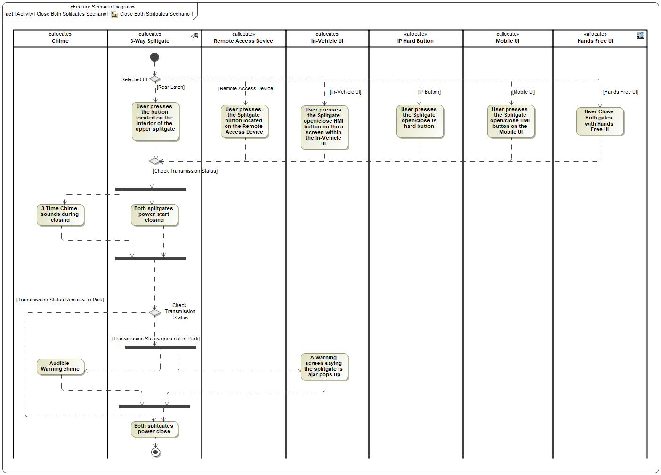

|  |
| --- |
| **Flow of Actions** |

Close Lower Splitgate Scenario

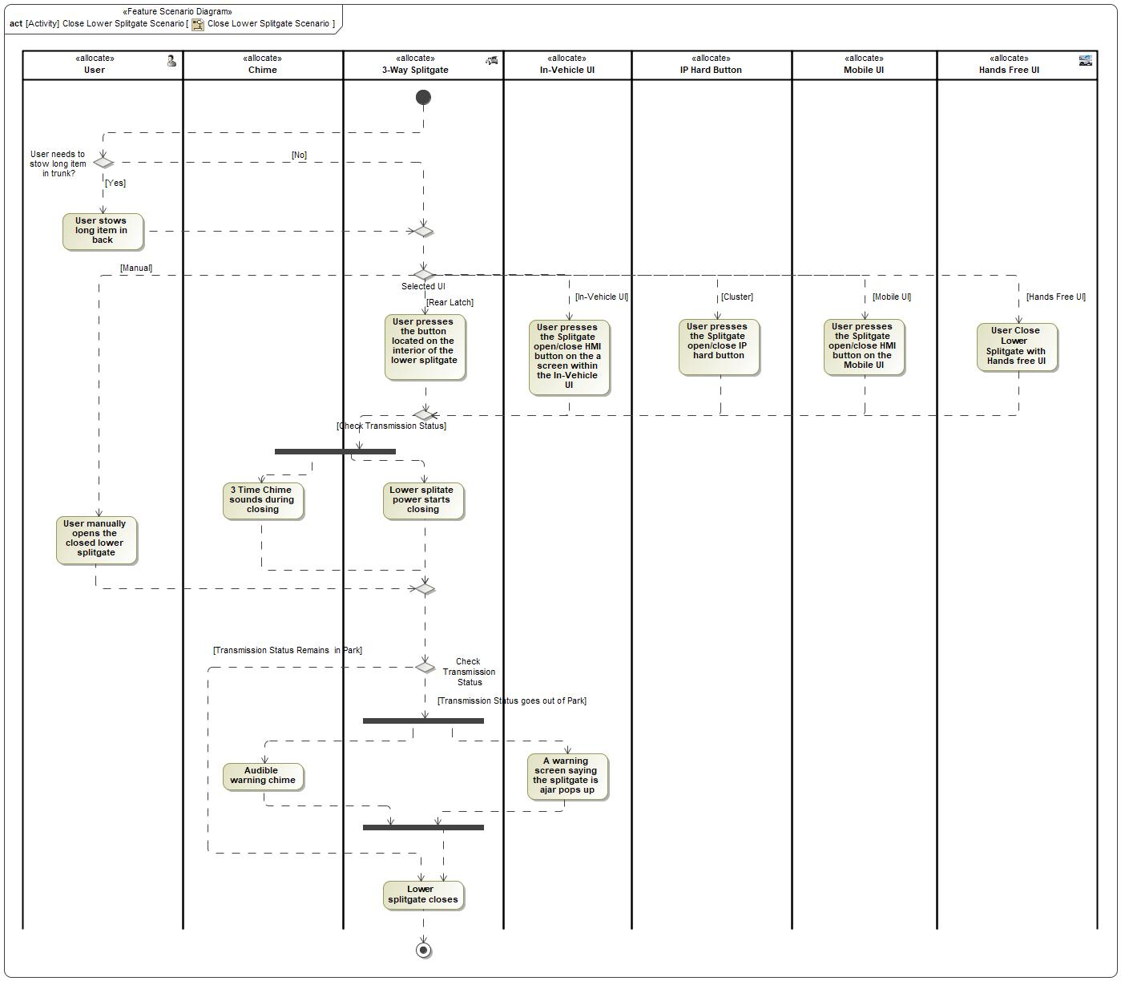

|  |
| --- |
| **Flow of Actions** |

Close Top Splitgate Scenario

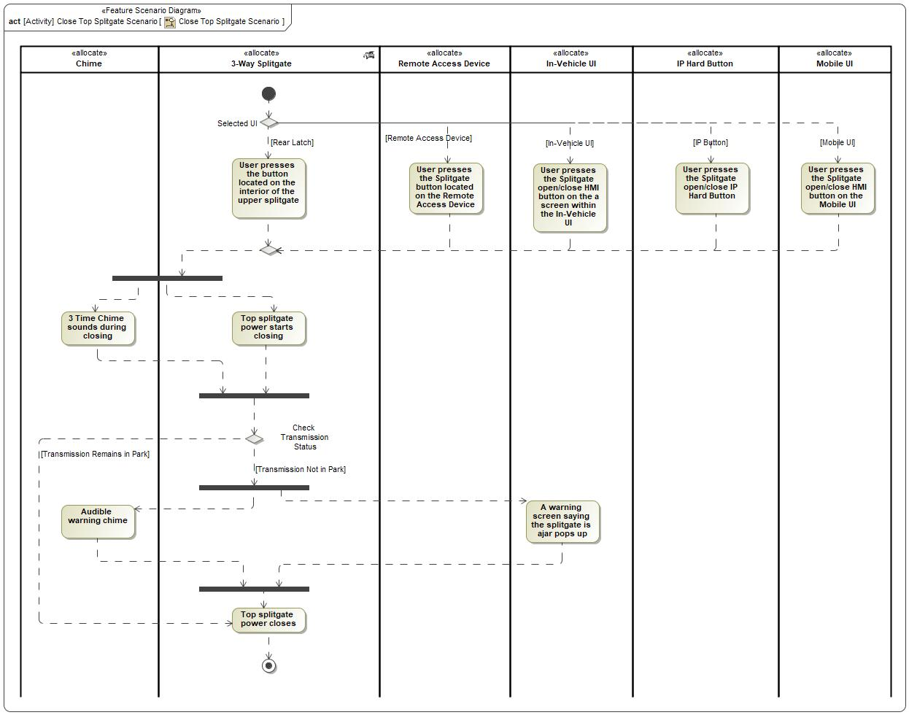

|  |
| --- |
| **Flow of Actions** |

Improve User Experience Scenario

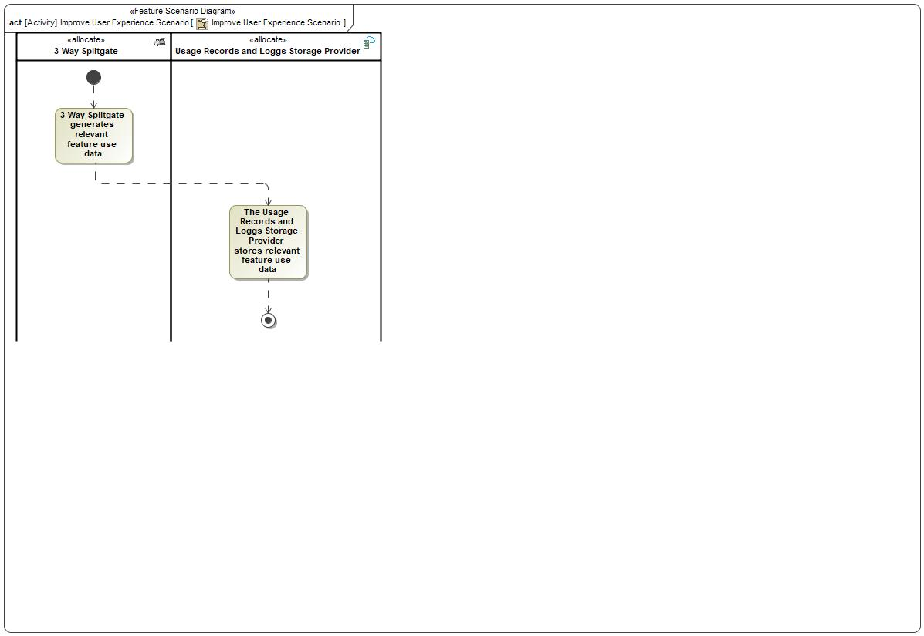

|  |  |
| --- | --- |
| **Flow of Actions** | |
| 1 | 3-Way Splitgate generates relevant feature use data |
| 2 | The Usage Records and Loggs Storage Provider stores relevant feature use data |

Manually Open Compartment on Tailgate Scenario

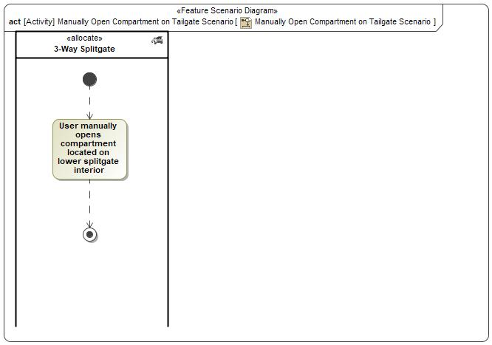

|  |  |
| --- | --- |
| **Flow of Actions** | |
| 1 |  |

Open Both Splitgates Scenario

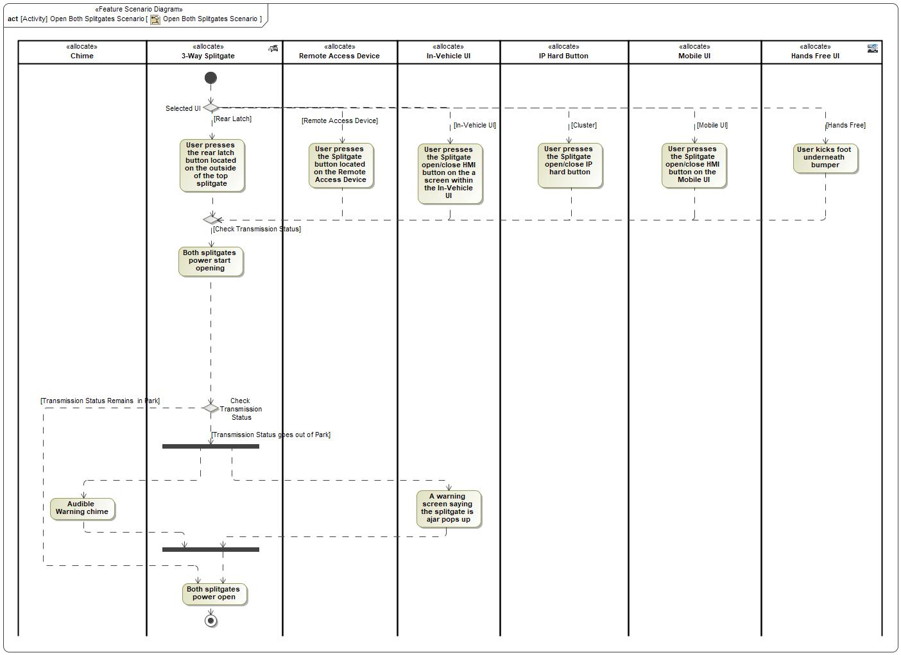

|  |
| --- |
| **Flow of Actions** |

Open Lower Splitgate Scenario

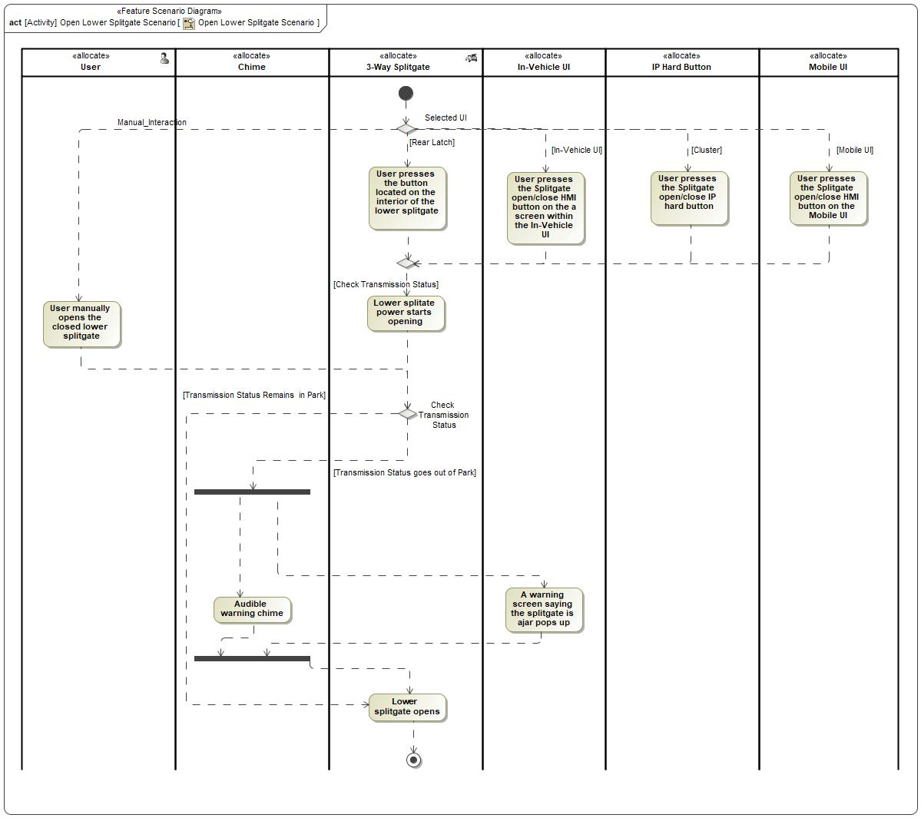

|  |
| --- |
| **Flow of Actions** |

Open Top Splitgate Scenario

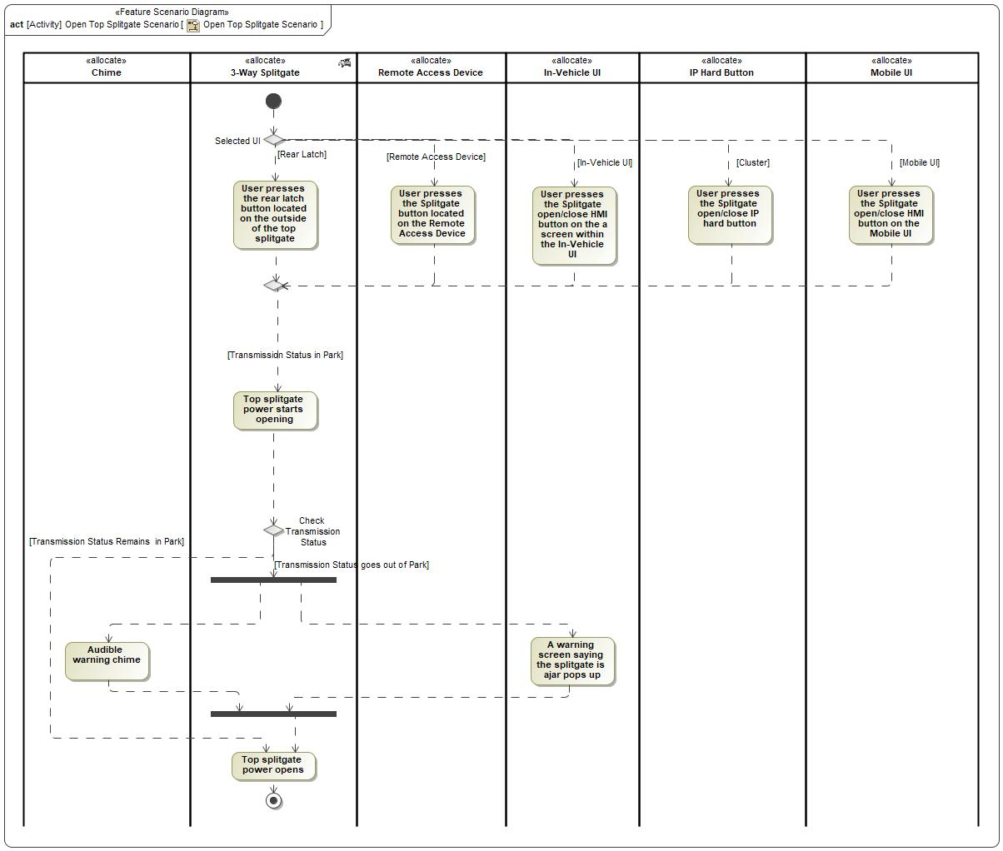

|  |
| --- |
| **Flow of Actions** |

Open Upper Splitgate in a Short Space Scenario

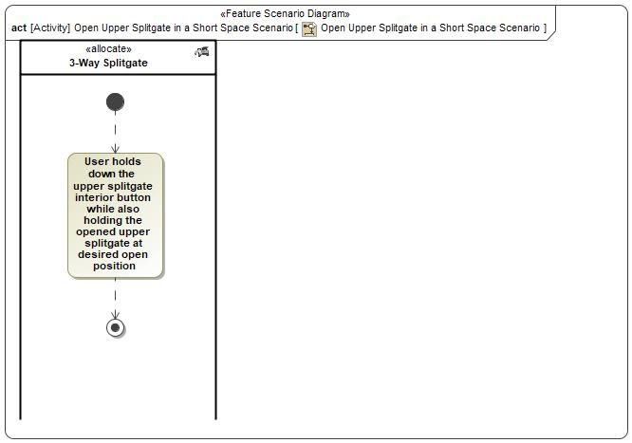

|  |  |
| --- | --- |
| **Flow of Actions** | |
| 1 |  |

Use Splitgate with Rear Latch or Remote Access Device to my Personal Preference Scenario

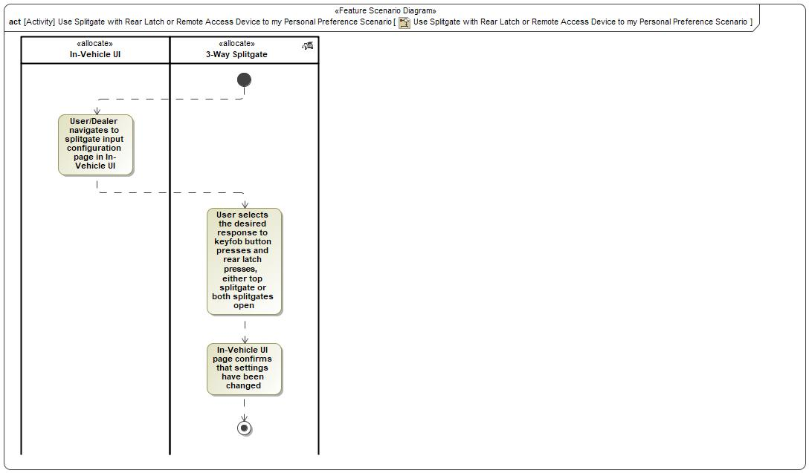

|  |  |
| --- | --- |
| **Flow of Actions** | |
| 1 |  |
| 2 |  |
| 3 |  |

## Decision Tables

*Not supported by MagicDraw report generation.*

# Feature Requirements

## Functional Requirements

R_F_3 Way Splitgate_0001 Required User Request Sources

The 3 Way Splitgate Feature shall provide users with the following input sources to request the operation:

-Rear latch button on the exterior of the liftgate

-Remote access device (Keyfob)

-In-Vehicle UI(SYNC)

-Mobile UI(Ford Pass)

-IP hard button

-Hand free UI

-Tailgate shutface button

-Liftgate shutface button

|  |  |  |  |  |  |  |  |
| --- | --- | --- | --- | --- | --- | --- | --- |
| Requirement ID: R_F_3 Way Splitgate_0001 | | | | | | | |
| **Rationale** |  | | | | | | |
| **Acceptance Criteria** |  | | | | | | |
| **Notes** |  | | | | | | |
| **Source** |  | | | | | **Owner** |  |
| **Source Req.** |  | | | | | **V&V Method** |  |
| **Type** |  | | | **Priority** |  | **Status** | In-Progress |
| [Req. Template](http://wiki.ford.com/display/RequirementsEngineering/Requirements+Attributes) Version | | 6.0 | End of Requirement | | | | |

R_F_3-Way-Splitgate_0002 User Request Source Configurability

The 3-Way Splitgate feature shall provide the user separate screen to configure the input source on SYNC.

|  |  |  |  |  |  |  |  |
| --- | --- | --- | --- | --- | --- | --- | --- |
| Requirement ID: R_F_3-Way-Splitgate_0002 | | | | | | | |
| **Rationale** |  | | | | | | |
| **Acceptance Criteria** |  | | | | | | |
| **Notes** |  | | | | | | |
| **Source** |  | | | | | **Owner** |  |
| **Source Req.** |  | | | | | **V&V Method** |  |
| **Type** |  | | | **Priority** |  | **Status** | In-Progress |
| [Req. Template](http://wiki.ford.com/display/RequirementsEngineering/Requirements+Attributes) Version | | 6.0 | End of Requirement | | | | |

R_F_3-Way-Splitgate_0003 3-way splitgate operation configurability

The 3-Way Splitgate feature shall provide the user a choice to select between the following splitgate power operation on SYNC screen. 1.Only liftgate power operation

2.liftgate and tailgate power operation

|  |  |  |  |  |  |  |  |
| --- | --- | --- | --- | --- | --- | --- | --- |
| Requirement ID: R_F_3-Way-Splitgate_0003 | | | | | | | |
| **Rationale** |  | | | | | | |
| **Acceptance Criteria** |  | | | | | | |
| **Notes** |  | | | | | | |
| **Source** |  | | | | | **Owner** |  |
| **Source Req.** |  | | | | | **V&V Method** |  |
| **Type** |  | | | **Priority** |  | **Status** | In-Progress |
| [Req. Template](http://wiki.ford.com/display/RequirementsEngineering/Requirements+Attributes) Version | | 6.0 | End of Requirement | | | | |

R_F_3-Way-Splitgate_0004 Enable Operation From Exterior Devices

The 3-Way Splitgate feature shall provide the user rear latch button on the exterior of the liftgate to open liftgate when the following conditions holds:

o Both splitgates are closed

o Rear latch and Remote Access Device are configured to control top splitgate only

o Transmission status is in park mode

|  |  |  |  |  |  |  |  |
| --- | --- | --- | --- | --- | --- | --- | --- |
| Requirement ID: R_F_3-Way-Splitgate_0004 | | | | | | | |
| **Rationale** |  | | | | | | |
| **Acceptance Criteria** |  | | | | | | |
| **Notes** |  | | | | | | |
| **Source** |  | | | | | **Owner** |  |
| **Source Req.** |  | | | | | **V&V Method** |  |
| **Type** |  | | | **Priority** |  | **Status** | In-Progress |
| [Req. Template](http://wiki.ford.com/display/RequirementsEngineering/Requirements+Attributes) Version | | 6.0 | End of Requirement | | | | |

R_F_3-Way-Splitgate_0005 User input from exterior switch on liftgate to perform liftgate power open operation

The 3-Way Splitgate feature shall provide the user a button on the exterior of the liftgate to open liftgate when the following conditions holds:

-Both splitgates are closed

-Transmission status is in park mode

-Configured to operate liftgate only

|  |  |  |  |  |  |  |  |
| --- | --- | --- | --- | --- | --- | --- | --- |
| Requirement ID: R_F_3-Way-Splitgate_0005 | | | | | | | |
| **Rationale** |  | | | | | | |
| **Acceptance Criteria** |  | | | | | | |
| **Notes** |  | | | | | | |
| **Source** |  | | | | | **Owner** |  |
| **Source Req.** |  | | | | | **V&V Method** |  |
| **Type** |  | | | **Priority** |  | **Status** | In-Progress |
| [Req. Template](http://wiki.ford.com/display/RequirementsEngineering/Requirements+Attributes) Version | | 6.0 | End of Requirement | | | | |

R_F_3-Way-Splitgate_0006 User Input from keyfob to perform liftgate power open operation

The 3-Way Splitgate feature shall provide the user an HMI button on Keyfob to open liftgate when the following conditions holds: -Both splitgates are closed. -Configured to operate liftgate only.

-Transmission status is in park mode.

|  |  |  |  |  |  |  |  |
| --- | --- | --- | --- | --- | --- | --- | --- |
| Requirement ID: R_F_3-Way-Splitgate_0006 | | | | | | | |
| **Rationale** |  | | | | | | |
| **Acceptance Criteria** |  | | | | | | |
| **Notes** |  | | | | | | |
| **Source** |  | | | | | **Owner** |  |
| **Source Req.** |  | | | | | **V&V Method** |  |
| **Type** |  | | | **Priority** |  | **Status** | In-Progress |
| [Req. Template](http://wiki.ford.com/display/RequirementsEngineering/Requirements+Attributes) Version | | 6.0 | End of Requirement | | | | |

R_F_3-Way-Splitgate_0007 User Input from SYNC to perform liftgate power open operation

The 3-Way Splitgate feature shall provide the user soft button on SYNC screen for Lincoln to open liftgate when the following conditions holds: -Both splitgates are closed.

-Configured to operate liftgate only.

-Transmission status is in park mode.

|  |  |  |  |  |  |  |  |
| --- | --- | --- | --- | --- | --- | --- | --- |
| Requirement ID: R_F_3-Way-Splitgate_0007 | | | | | | | |
| **Rationale** |  | | | | | | |
| **Acceptance Criteria** |  | | | | | | |
| **Notes** |  | | | | | | |
| **Source** |  | | | | | **Owner** |  |
| **Source Req.** |  | | | | | **V&V Method** |  |
| **Type** |  | | | **Priority** |  | **Status** | In-Progress |
| [Req. Template](http://wiki.ford.com/display/RequirementsEngineering/Requirements+Attributes) Version | | 6.0 | End of Requirement | | | | |

R_F_3-Way-Splitgate_0008 User Input from FordPass to perform liftgate power open operation

The 3-Way Splitgate feature shall provide the user FordPass mobile UI to open liftgate when the following conditions holds: -Both splitgates are closed.

-Configured to operate liftgate only.

-Transmission status is in park mode.

|  |  |  |  |  |  |  |  |
| --- | --- | --- | --- | --- | --- | --- | --- |
| Requirement ID: R_F_3-Way-Splitgate_0008 | | | | | | | |
| **Rationale** |  | | | | | | |
| **Acceptance Criteria** |  | | | | | | |
| **Notes** |  | | | | | | |
| **Source** |  | | | | | **Owner** |  |
| **Source Req.** |  | | | | | **V&V Method** |  |
| **Type** |  | | | **Priority** |  | **Status** | In-Progress |
| [Req. Template](http://wiki.ford.com/display/RequirementsEngineering/Requirements+Attributes) Version | | 6.0 | End of Requirement | | | | |

R_F_3-Way-Splitgate_0009 User Input from IP hard button to perform liftgate power open operation

The 3-Way Splitgate feature shall provide the user IP hard button for Expedition to open liftgate when the following conditions holds: -Both splitgates are closed.

-Configured to operate liftgate only.

-Transmission status is in park mode. .

|  |  |  |  |  |  |  |  |
| --- | --- | --- | --- | --- | --- | --- | --- |
| Requirement ID: R_F_3-Way-Splitgate_0009 | | | | | | | |
| **Rationale** |  | | | | | | |
| **Acceptance Criteria** |  | | | | | | |
| **Notes** |  | | | | | | |
| **Source** |  | | | | | **Owner** |  |
| **Source Req.** |  | | | | | **V&V Method** |  |
| **Type** |  | | | **Priority** |  | **Status** | In-Progress |
| [Req. Template](http://wiki.ford.com/display/RequirementsEngineering/Requirements+Attributes) Version | | 6.0 | End of Requirement | | | | |

R_F_3-Way-Splitgate_0010 User Input from hand free UI to perform liftgate power open operation

The 3-Way Splitgate feature shall provide the user a hand free sensor underneath the bumper to open liftgate when the following conditions holds: -Both splitgates are closed

-Configured to operate liftgate only.

-Transmission status is in park

|  |  |  |  |  |  |  |  |
| --- | --- | --- | --- | --- | --- | --- | --- |
| Requirement ID: R_F_3-Way-Splitgate_0010 | | | | | | | |
| **Rationale** |  | | | | | | |
| **Acceptance Criteria** |  | | | | | | |
| **Notes** |  | | | | | | |
| **Source** |  | | | | | **Owner** |  |
| **Source Req.** |  | | | | | **V&V Method** |  |
| **Type** |  | | | **Priority** |  | **Status** | In-Progress |
| [Req. Template](http://wiki.ford.com/display/RequirementsEngineering/Requirements+Attributes) Version | | 6.0 | End of Requirement | | | | |

R_F_3-Way-Splitgate_0011 User input from exterior switch on liftgate to perform both splitgates open operation

The 3-Way Splitgate feature shall provide the user a button on the exterior of the liftgate to open splitgates when the following conditions holds: -Both splitgates are closed

-Configured to operate both splitgates .

-Transmission status is in park

|  |  |  |  |  |  |  |  |
| --- | --- | --- | --- | --- | --- | --- | --- |
| Requirement ID: R_F_3-Way-Splitgate_0011 | | | | | | | |
| **Rationale** |  | | | | | | |
| **Acceptance Criteria** |  | | | | | | |
| **Notes** |  | | | | | | |
| **Source** |  | | | | | **Owner** |  |
| **Source Req.** |  | | | | | **V&V Method** |  |
| **Type** |  | | | **Priority** |  | **Status** | In-Progress |
| [Req. Template](http://wiki.ford.com/display/RequirementsEngineering/Requirements+Attributes) Version | | 6.0 | End of Requirement | | | | |

R_F_3-Way-Splitgate_0012 User Input from keyfob to perform both splitgate power open operation

The 3-Way Splitgate feature shall provide the user an HMI button on Keyfob to open both splitgates when the following conditions holds: -Both splitgates are closed

-Configured to operate both splitgates.

-Transmission status is in park

|  |  |  |  |  |  |  |  |
| --- | --- | --- | --- | --- | --- | --- | --- |
| Requirement ID: R_F_3-Way-Splitgate_0012 | | | | | | | |
| **Rationale** |  | | | | | | |
| **Acceptance Criteria** |  | | | | | | |
| **Notes** |  | | | | | | |
| **Source** |  | | | | | **Owner** |  |
| **Source Req.** |  | | | | | **V&V Method** |  |
| **Type** |  | | | **Priority** |  | **Status** | In-Progress |
| [Req. Template](http://wiki.ford.com/display/RequirementsEngineering/Requirements+Attributes) Version | | 6.0 | End of Requirement | | | | |

R_F_3-Way-Splitgate_0013 User input from SYNC to perform both splitgates power open operation

The 3-Way Splitgate feature shall provide the user soft button on SYNC screen for Lincoln to open both splitgates when the following conditions holds: -Both splitgates are closed

-Configured to operate both splitgates.

-Transmission status is in park

|  |  |  |  |  |  |  |  |
| --- | --- | --- | --- | --- | --- | --- | --- |
| Requirement ID: R_F_3-Way-Splitgate_0013 | | | | | | | |
| **Rationale** |  | | | | | | |
| **Acceptance Criteria** |  | | | | | | |
| **Notes** |  | | | | | | |
| **Source** |  | | | | | **Owner** |  |
| **Source Req.** |  | | | | | **V&V Method** |  |
| **Type** |  | | | **Priority** |  | **Status** | In-Progress |
| [Req. Template](http://wiki.ford.com/display/RequirementsEngineering/Requirements+Attributes) Version | | 6.0 | End of Requirement | | | | |

R_F_3-Way-Splitgate_0014 User input from FordPass to perform both splitgates power open operation

The 3-Way Splitgate feature shall provide the user FordPass mobile UI to open both splitgates when the following conditions holds: -Both splitgates are closed

-Configured to operate both splitgates.

-Transmission status is in park

|  |  |  |  |  |  |  |  |
| --- | --- | --- | --- | --- | --- | --- | --- |
| Requirement ID: R_F_3-Way-Splitgate_0014 | | | | | | | |
| **Rationale** |  | | | | | | |
| **Acceptance Criteria** |  | | | | | | |
| **Notes** |  | | | | | | |
| **Source** |  | | | | | **Owner** |  |
| **Source Req.** |  | | | | | **V&V Method** |  |
| **Type** |  | | | **Priority** |  | **Status** | In-Progress |
| [Req. Template](http://wiki.ford.com/display/RequirementsEngineering/Requirements+Attributes) Version | | 6.0 | End of Requirement | | | | |

R_F_3-Way-Splitgate_0015 User Input from IP hard buttons to perform both splitgates power open operation

The 3-Way Splitgate feature shall provide the user IP hard button for Expedition to open both splitgates when the following conditions holds: -Both splitgates are closed

-Configured to operate both splitgates.

-Transmission status is in park

|  |  |  |  |  |  |  |  |
| --- | --- | --- | --- | --- | --- | --- | --- |
| Requirement ID: R_F_3-Way-Splitgate_0015 | | | | | | | |
| **Rationale** |  | | | | | | |
| **Acceptance Criteria** |  | | | | | | |
| **Notes** |  | | | | | | |
| **Source** |  | | | | | **Owner** |  |
| **Source Req.** |  | | | | | **V&V Method** |  |
| **Type** |  | | | **Priority** |  | **Status** | In-Progress |
| [Req. Template](http://wiki.ford.com/display/RequirementsEngineering/Requirements+Attributes) Version | | 6.0 | End of Requirement | | | | |

R_F_3-Way-Splitgate_0016 User Input from hand free UI to perform both splitgates power open operation

The 3-Way Splitgate feature shall provide the user a hand free sensor underneath the bumper to open both splitgates when the following conditions holds: -Both splitgates are closed

-Configured to operate both splitgates.

-Transmission status is in park

|  |  |  |  |  |  |  |  |
| --- | --- | --- | --- | --- | --- | --- | --- |
| Requirement ID: R_F_3-Way-Splitgate_0016 | | | | | | | |
| **Rationale** |  | | | | | | |
| **Acceptance Criteria** |  | | | | | | |
| **Notes** |  | | | | | | |
| **Source** |  | | | | | **Owner** |  |
| **Source Req.** |  | | | | | **V&V Method** |  |
| **Type** |  | | | **Priority** |  | **Status** | In-Progress |
| [Req. Template](http://wiki.ford.com/display/RequirementsEngineering/Requirements+Attributes) Version | | 6.0 | End of Requirement | | | | |

R_F_3-Way-Splitgate_0017 User input from tailgate shutface button to perform power tailgate open operation

The 3-Way Splitgate feature shall provide the user a tailgate shutface button to open tailgate when the following conditions holds: -Tailgate is closed. -Liftgate is open.

-Transmission status is in park.

|  |  |  |  |  |  |  |  |
| --- | --- | --- | --- | --- | --- | --- | --- |
| Requirement ID: R_F_3-Way-Splitgate_0017 | | | | | | | |
| **Rationale** |  | | | | | | |
| **Acceptance Criteria** |  | | | | | | |
| **Notes** |  | | | | | | |
| **Source** |  | | | | | **Owner** |  |
| **Source Req.** |  | | | | | **V&V Method** |  |
| **Type** |  | | | **Priority** |  | **Status** | In-Progress |
| [Req. Template](http://wiki.ford.com/display/RequirementsEngineering/Requirements+Attributes) Version | | 6.0 | End of Requirement | | | | |

R_F_3-Way-Splitgate_0018 User input to perform tailgate manual open operation

The 3-Way Splitgate feature shall provide the user a soft button on the SYNC to configure to open tailgate manually when the following condition holds:

-Tailgate is closed.

-Liftgate is open.

-Transmission status is in park.

-Configured to operate Manually tailgate only.

|  |  |  |  |  |  |  |  |
| --- | --- | --- | --- | --- | --- | --- | --- |
| Requirement ID: R_F_3-Way-Splitgate_0018 | | | | | | | |
| **Rationale** |  | | | | | | |
| **Acceptance Criteria** |  | | | | | | |
| **Notes** |  | | | | | | |
| **Source** |  | | | | | **Owner** |  |
| **Source Req.** |  | | | | | **V&V Method** |  |
| **Type** |  | | | **Priority** |  | **Status** | In-Progress |
| [Req. Template](http://wiki.ford.com/display/RequirementsEngineering/Requirements+Attributes) Version | | 6.0 | End of Requirement | | | | |

R_F_3-Way-Splitgate_0019 User Input from liftgate shutface button to perform liftgate power close operation

The 3-Way Splitgate feature shall provide the user a liftgate shutface button to close the liftgate when the following condition holds:

-Liftgate is open

-Tailgate is closed.

-Transmission status is in park. -Tailgate is closed. -Transmission status is in park.

|  |  |  |  |  |  |  |  |
| --- | --- | --- | --- | --- | --- | --- | --- |
| Requirement ID: R_F_3-Way-Splitgate_0019 | | | | | | | |
| **Rationale** |  | | | | | | |
| **Acceptance Criteria** |  | | | | | | |
| **Notes** | Reference RQT-011421-015387System Lockout | | | | | | |
| **Source** |  | | | | | **Owner** |  |
| **Source Req.** |  | | | | | **V&V Method** |  |
| **Type** |  | | | **Priority** |  | **Status** | In-Progress |
| [Req. Template](http://wiki.ford.com/display/RequirementsEngineering/Requirements+Attributes) Version | | 6.0 | End of Requirement | | | | |

R_F_3-Way-Splitgate_0020 User Input from IP hard button to perform liftgate power close operation

The 3-Way Splitgate feature shall provide the user a IP hard button on Expedition to close the liftgate when the following condition holds:

-Liftgate is open -Tailgate is closed. -Transmission status is in park.

-Configured to operate liftgate only.

|  |  |  |  |  |  |  |  |
| --- | --- | --- | --- | --- | --- | --- | --- |
| Requirement ID: R_F_3-Way-Splitgate_0020 | | | | | | | |
| **Rationale** |  | | | | | | |
| **Acceptance Criteria** |  | | | | | | |
| **Notes** |  | | | | | | |
| **Source** |  | | | | | **Owner** |  |
| **Source Req.** |  | | | | | **V&V Method** |  |
| **Type** |  | | | **Priority** |  | **Status** | In-Progress |
| [Req. Template](http://wiki.ford.com/display/RequirementsEngineering/Requirements+Attributes) Version | | 6.0 | End of Requirement | | | | |

R_F_3-Way-Splitgate_0021 User Input from keyfob to perform liftgate power close operation

The 3-Way Splitgate feature shall provide the user a Keyfob button to close the liftgate when the following conditons holds:

-Liftgate is open

-Tailgate is closed

-Transmission status is in park

-Configured to operate liftgate only.

|  |  |  |  |  |  |  |  |
| --- | --- | --- | --- | --- | --- | --- | --- |
| Requirement ID: R_F_3-Way-Splitgate_0021 | | | | | | | |
| **Rationale** |  | | | | | | |
| **Acceptance Criteria** |  | | | | | | |
| **Notes** |  | | | | | | |
| **Source** |  | | | | | **Owner** |  |
| **Source Req.** |  | | | | | **V&V Method** |  |
| **Type** |  | | | **Priority** |  | **Status** | In-Progress |
| [Req. Template](http://wiki.ford.com/display/RequirementsEngineering/Requirements+Attributes) Version | | 6.0 | End of Requirement | | | | |

R_F_3-Way-Splitgate_0022 User Input from SYNC to perform liftgate power close by In-Vehicle UI

The 3-Way Splitgate feature shall provide the user a soft button on the SYNC screen for Lincoln to close liftgate when the following conditons holds:

-Liftgate is open -Tailgate is closed -Transmission status is in park

-Configured to operate both splitgates

|  |  |  |  |  |  |  |  |
| --- | --- | --- | --- | --- | --- | --- | --- |
| Requirement ID: R_F_3-Way-Splitgate_0022 | | | | | | | |
| **Rationale** |  | | | | | | |
| **Acceptance Criteria** |  | | | | | | |
| **Notes** |  | | | | | | |
| **Source** |  | | | | | **Owner** |  |
| **Source Req.** |  | | | | | **V&V Method** |  |
| **Type** |  | | | **Priority** |  | **Status** | In-Progress |
| [Req. Template](http://wiki.ford.com/display/RequirementsEngineering/Requirements+Attributes) Version | | 6.0 | End of Requirement | | | | |

R_F_3-Way-Splitgate_0023 User Input from FordPass to perform liftgate power close operation

The 3-Way Splitgate feature shall provide the user FordPass mobile UI to close the liftgate when the following conditons holds:

-Liftgate is open -Tailgate is closed

-Transmission status is in park

-Configured to operate liftgate only. -Transmission status is in park -Configured to operate liftgate only.

|  |  |  |  |  |  |  |  |
| --- | --- | --- | --- | --- | --- | --- | --- |
| Requirement ID: R_F_3-Way-Splitgate_0023 | | | | | | | |
| **Rationale** |  | | | | | | |
| **Acceptance Criteria** |  | | | | | | |
| **Notes** |  | | | | | | |
| **Source** |  | | | | | **Owner** |  |
| **Source Req.** |  | | | | | **V&V Method** |  |
| **Type** |  | | | **Priority** |  | **Status** | In-Progress |
| [Req. Template](http://wiki.ford.com/display/RequirementsEngineering/Requirements+Attributes) Version | | 6.0 | End of Requirement | | | | |

R_F_3-Way-Splitgate_0024 User Input to perform liftgate close operation manually

The 3-Way Splitgate feature shall provide the user to close liftgate manually when the following conditons holds:

-Liftgate is open -Tailgate is closed -Transmission status is in park

-Configured to operate Manually liftgate only

|  |  |  |  |  |  |  |  |
| --- | --- | --- | --- | --- | --- | --- | --- |
| Requirement ID: R_F_3-Way-Splitgate_0024 | | | | | | | |
| **Rationale** |  | | | | | | |
| **Acceptance Criteria** |  | | | | | | |
| **Notes** |  | | | | | | |
| **Source** |  | | | | | **Owner** |  |
| **Source Req.** |  | | | | | **V&V Method** |  |
| **Type** |  | | | **Priority** |  | **Status** | In-Progress |
| [Req. Template](http://wiki.ford.com/display/RequirementsEngineering/Requirements+Attributes) Version | | 6.0 | End of Requirement | | | | |

R_F_3-Way-Splitgate_0025 User Input from liftgate shutface button to perform both splitgates power close operation

The 3-Way Splitgate feature shall provide the user a liftgate shutface button to close both splitgates when the following conditons holds:

-Both spligates are open. -Transmission status is in park.

-Configured to operate both splitgates.

|  |  |  |  |  |  |  |  |
| --- | --- | --- | --- | --- | --- | --- | --- |
| Requirement ID: R_F_3-Way-Splitgate_0025 | | | | | | | |
| **Rationale** |  | | | | | | |
| **Acceptance Criteria** |  | | | | | | |
| **Notes** |  | | | | | | |
| **Source** |  | | | | | **Owner** |  |
| **Source Req.** |  | | | | | **V&V Method** |  |
| **Type** |  | | | **Priority** |  | **Status** | In-Progress |
| [Req. Template](http://wiki.ford.com/display/RequirementsEngineering/Requirements+Attributes) Version | | 6.0 | End of Requirement | | | | |

R_F_3-Way-Splitgate_0026 User Input from keyfob to perform both splitgates power close operation

The 3-Way Splitgate feature shall provide the user an HMI button on Keyfob to close both splitgates when the following conditons holds:

-Both spligates are open

-Transmission status is in park

-Configured to operate both splitgates. -Transmission status is in park -Configured to operate both splitgates.

|  |  |  |  |  |  |  |  |
| --- | --- | --- | --- | --- | --- | --- | --- |
| Requirement ID: R_F_3-Way-Splitgate_0026 | | | | | | | |
| **Rationale** |  | | | | | | |
| **Acceptance Criteria** |  | | | | | | |
| **Notes** |  | | | | | | |
| **Source** |  | | | | | **Owner** |  |
| **Source Req.** |  | | | | | **V&V Method** |  |
| **Type** |  | | | **Priority** |  | **Status** | In-Progress |
| [Req. Template](http://wiki.ford.com/display/RequirementsEngineering/Requirements+Attributes) Version | | 6.0 | End of Requirement | | | | |

R_F_3-Way-Splitgate_0027 User Input from SYNC to perform both splitgates power close operation

The 3-Way Splitgate feature shall provide the user a soft button on the SYNC screen on Lincoln to close both splitgates when the following conditons holds:

-Both spligates are open -Transmission status is in park

-Configured to operate both splitgates.

|  |  |  |  |  |  |  |  |
| --- | --- | --- | --- | --- | --- | --- | --- |
| Requirement ID: R_F_3-Way-Splitgate_0027 | | | | | | | |
| **Rationale** |  | | | | | | |
| **Acceptance Criteria** |  | | | | | | |
| **Notes** |  | | | | | | |
| **Source** |  | | | | | **Owner** |  |
| **Source Req.** |  | | | | | **V&V Method** |  |
| **Type** |  | | | **Priority** |  | **Status** | In-Progress |
| [Req. Template](http://wiki.ford.com/display/RequirementsEngineering/Requirements+Attributes) Version | | 6.0 | End of Requirement | | | | |

R_F_3-Way-Splitgate_0028 User Input from IP hard button to perform both splitgates power close operation

The 3-Way Splitgate feature shall provide the user a IP hard button at Expedition to close both splitgates when the following conditons holds:

-Both spligates are open -Transmission status is in park

-Configured to operate both splitgates.

|  |  |  |  |  |  |  |  |
| --- | --- | --- | --- | --- | --- | --- | --- |
| Requirement ID: R_F_3-Way-Splitgate_0028 | | | | | | | |
| **Rationale** |  | | | | | | |
| **Acceptance Criteria** |  | | | | | | |
| **Notes** |  | | | | | | |
| **Source** |  | | | | | **Owner** |  |
| **Source Req.** |  | | | | | **V&V Method** |  |
| **Type** |  | | | **Priority** |  | **Status** | In-Progress |
| [Req. Template](http://wiki.ford.com/display/RequirementsEngineering/Requirements+Attributes) Version | | 6.0 | End of Requirement | | | | |

R_F_3-Way-Splitgate_0029 User Input from FordPass to perform both splitgates power close operation

The 3-Way Splitgate feature shall provide the user FordPass mobile UI to close both splitgates when the following conditons holds:

-Both spligates are open

-Transmission status is in park

-Configured to operate both splitgates. -Transmission status is in park -Configured to operate both splitgates.

|  |  |  |  |  |  |  |  |
| --- | --- | --- | --- | --- | --- | --- | --- |
| Requirement ID: R_F_3-Way-Splitgate_0029 | | | | | | | |
| **Rationale** |  | | | | | | |
| **Acceptance Criteria** |  | | | | | | |
| **Notes** |  | | | | | | |
| **Source** |  | | | | | **Owner** |  |
| **Source Req.** |  | | | | | **V&V Method** |  |
| **Type** |  | | | **Priority** |  | **Status** | In-Progress |
| [Req. Template](http://wiki.ford.com/display/RequirementsEngineering/Requirements+Attributes) Version | | 6.0 | End of Requirement | | | | |

R_F_3-Way-Splitgate_0030 User Input from hand free UI to perform both splitgates power close operation

The 3-Way Splitgate feature shall provide the user a hand free sensor underneath the bumper to close both splitgates when the following conditions holds:

-Both splitgates are open

-Configured to operate both splitgates.

-Transmission status is in park

|  |  |  |  |  |  |  |  |
| --- | --- | --- | --- | --- | --- | --- | --- |
| Requirement ID: R_F_3-Way-Splitgate_0030 | | | | | | | |
| **Rationale** |  | | | | | | |
| **Acceptance Criteria** |  | | | | | | |
| **Notes** |  | | | | | | |
| **Source** |  | | | | | **Owner** |  |
| **Source Req.** |  | | | | | **V&V Method** |  |
| **Type** |  | | | **Priority** |  | **Status** | In-Progress |
| [Req. Template](http://wiki.ford.com/display/RequirementsEngineering/Requirements+Attributes) Version | | 6.0 | End of Requirement | | | | |

R_F_3-Way-Splitgate_0031 User Input from tailgate shutface button to perform tailgate close operation

The 3-Way Splitgate feature shall provide the user a tailgate shutface button to close the tailgate when the following conditons holds:

-Both spligates are open

-Transmission status is in park

|  |  |  |  |  |  |  |  |
| --- | --- | --- | --- | --- | --- | --- | --- |
| Requirement ID: R_F_3-Way-Splitgate_0031 | | | | | | | |
| **Rationale** |  | | | | | | |
| **Acceptance Criteria** |  | | | | | | |
| **Notes** |  | | | | | | |
| **Source** |  | | | | | **Owner** |  |
| **Source Req.** |  | | | | | **V&V Method** |  |
| **Type** |  | | | **Priority** |  | **Status** | In-Progress |
| [Req. Template](http://wiki.ford.com/display/RequirementsEngineering/Requirements+Attributes) Version | | 6.0 | End of Requirement | | | | |

R_F_3-Way-Splitgate_0032 User Input to perform tailgate close operation manually

The 3-Way Splitgate feature shall provide the user a soft button on the SYNC to configure to close the tailgate manually when the following conditons holds:

-Both spligates are open -Transmission status is in park

-Configured to operate Manually tailgate only

|  |  |  |  |  |  |  |  |
| --- | --- | --- | --- | --- | --- | --- | --- |
| Requirement ID: R_F_3-Way-Splitgate_0032 | | | | | | | |
| **Rationale** |  | | | | | | |
| **Acceptance Criteria** |  | | | | | | |
| **Notes** |  | | | | | | |
| **Source** |  | | | | | **Owner** |  |
| **Source Req.** |  | | | | | **V&V Method** |  |
| **Type** |  | | | **Priority** |  | **Status** | In-Progress |
| [Req. Template](http://wiki.ford.com/display/RequirementsEngineering/Requirements+Attributes) Version | | 6.0 | End of Requirement | | | | |

R_F_3-Way-Splitgate_0033 Desired position of splitgate

The 3-Way Splitgate feature shall store the liftgate postion as the user selected open position when the liftgate shutface button is held for 3 seconds and chime once after the storage is complete.

|  |  |  |  |  |  |  |  |
| --- | --- | --- | --- | --- | --- | --- | --- |
| Requirement ID: R_F_3-Way-Splitgate_0033 | | | | | | | |
| **Rationale** |  | | | | | | |
| **Acceptance Criteria** |  | | | | | | |
| **Notes** |  | | | | | | |
| **Source** |  | | | | | **Owner** |  |
| **Source Req.** |  | | | | | **V&V Method** |  |
| **Type** |  | | | **Priority** |  | **Status** | In-Progress |
| [Req. Template](http://wiki.ford.com/display/RequirementsEngineering/Requirements+Attributes) Version | | 6.0 | End of Requirement | | | | |

R_F_3-Way-Splitgate_0034 Ajar Notification when tailgate is open

The 3-Way splitgate Feature shall notify the user that the door is ajar by an audible chime and visual feedback via the In-Vehicle UI when the following is true:

-Transmission status is out of park mode and tailgate is open

|  |  |  |  |  |  |  |  |
| --- | --- | --- | --- | --- | --- | --- | --- |
| Requirement ID: R_F_3-Way-Splitgate_0034 | | | | | | | |
| **Rationale** |  | | | | | | |
| **Acceptance Criteria** |  | | | | | | |
| **Notes** |  | | | | | | |
| **Source** |  | | | | | **Owner** |  |
| **Source Req.** |  | | | | | **V&V Method** |  |
| **Type** |  | | | **Priority** |  | **Status** | In-Progress |
| [Req. Template](http://wiki.ford.com/display/RequirementsEngineering/Requirements+Attributes) Version | | 6.0 | End of Requirement | | | | |

R_F_3-Way-Splitgate_0035 User Input to perform tailgate power close operation manually

The 3-Way splitgate Feature shall notify the user that the door is ajar by an audible chime and visual feedback via the In-Vehicle UI when the following is true:

-Transmission status is out of park mode and tailgate is not fully closed

|  |  |  |  |  |  |  |  |
| --- | --- | --- | --- | --- | --- | --- | --- |
| Requirement ID: R_F_3-Way-Splitgate_0035 | | | | | | | |
| **Rationale** |  | | | | | | |
| **Acceptance Criteria** |  | | | | | | |
| **Notes** |  | | | | | | |
| **Source** |  | | | | | **Owner** |  |
| **Source Req.** |  | | | | | **V&V Method** |  |
| **Type** |  | | | **Priority** |  | **Status** | In-Progress |
| [Req. Template](http://wiki.ford.com/display/RequirementsEngineering/Requirements+Attributes) Version | | 6.0 | End of Requirement | | | | |

R_F_3-Way-Splitgate_0165 No Power Operation When Liftgate Position is Not Known

The 3 Way Splitgate Feature shall not allow power operation when the liftgate position is not known.

|  |  |  |  |  |  |  |  |
| --- | --- | --- | --- | --- | --- | --- | --- |
| Requirement ID: R_F_3-Way-Splitgate_0165 | | | | | | | |
| **Rationale** |  | | | | | | |
| **Acceptance Criteria** |  | | | | | | |
| **Notes** |  | | | | | | |
| **Source** |  | | | | | **Owner** |  |
| **Source Req.** |  | | | | | **V&V Method** |  |
| **Type** |  | | | **Priority** |  | **Status** | In-Progress |
| [Req. Template](http://wiki.ford.com/display/RequirementsEngineering/Requirements+Attributes) Version | | 6.0 | End of Requirement | | | | |

R_F_3-Way-Splitgate_0166 No Power Operation When Tailgate Position is Not Known (Power variant)

The 3 Way Splitgate Feature shall not allow power operation when the tailgate position is not known.

|  |  |  |  |  |  |  |  |
| --- | --- | --- | --- | --- | --- | --- | --- |
| Requirement ID: R_F_3-Way-Splitgate_0166 | | | | | | | |
| **Rationale** |  | | | | | | |
| **Acceptance Criteria** |  | | | | | | |
| **Notes** |  | | | | | | |
| **Source** |  | | | | | **Owner** |  |
| **Source Req.** |  | | | | | **V&V Method** |  |
| **Type** |  | | | **Priority** |  | **Status** | In-Progress |
| [Req. Template](http://wiki.ford.com/display/RequirementsEngineering/Requirements+Attributes) Version | | 6.0 | End of Requirement | | | | |

R_F_3-Way-Splitgate_0167 No Power Operation When Tailgate Latch state is Not Known (Manual variant)

The 3 Way Splitgate Feature shall not allow power operation when the tailgate latch state is not known.

|  |  |  |  |  |  |  |  |
| --- | --- | --- | --- | --- | --- | --- | --- |
| Requirement ID: R_F_3-Way-Splitgate_0167 | | | | | | | |
| **Rationale** |  | | | | | | |
| **Acceptance Criteria** |  | | | | | | |
| **Notes** |  | | | | | | |
| **Source** |  | | | | | **Owner** |  |
| **Source Req.** |  | | | | | **V&V Method** |  |
| **Type** |  | | | **Priority** |  | **Status** | In-Progress |
| [Req. Template](http://wiki.ford.com/display/RequirementsEngineering/Requirements+Attributes) Version | | 6.0 | End of Requirement | | | | |

R_F_3-Way-Splitgate_0168 Allow Power Open Operation From Fully Closed Position

When a liftgate power open operation is active and the full open position has not yet been determined, the 3 Way Splitgate Feature shall continue the power open operation and monitor liftgate position relative to the fully closed position until the mechanical full open position has been reached. Once the mechanical full open has been reached, the 3 Way Splitgate Feature shall store the liftgate position as the full open position.

|  |  |  |  |  |  |  |  |
| --- | --- | --- | --- | --- | --- | --- | --- |
| Requirement ID: R_F_3-Way-Splitgate_0168 | | | | | | | |
| **Rationale** |  | | | | | | |
| **Acceptance Criteria** |  | | | | | | |
| **Notes** |  | | | | | | |
| **Source** |  | | | | | **Owner** |  |
| **Source Req.** |  | | | | | **V&V Method** |  |
| **Type** |  | | | **Priority** |  | **Status** | In-Progress |
| [Req. Template](http://wiki.ford.com/display/RequirementsEngineering/Requirements+Attributes) Version | | 6.0 | End of Requirement | | | | |

R_F_3-Way-Splitgate_0169 Learning Liftgate Full Open Position

The 3 Way Splitgate Feature shall not allow power operation when the tailgate position is not known.

|  |  |  |  |  |  |  |  |
| --- | --- | --- | --- | --- | --- | --- | --- |
| Requirement ID: R_F_3-Way-Splitgate_0169 | | | | | | | |
| **Rationale** |  | | | | | | |
| **Acceptance Criteria** |  | | | | | | |
| **Notes** |  | | | | | | |
| **Source** |  | | | | | **Owner** |  |
| **Source Req.** |  | | | | | **V&V Method** |  |
| **Type** |  | | | **Priority** |  | **Status** | In-Progress |
| [Req. Template](http://wiki.ford.com/display/RequirementsEngineering/Requirements+Attributes) Version | | 6.0 | End of Requirement | | | | |

R_F_3-Way_Splitgate_0036 User Request While Power Movement in Progress_01

The 3-Way splitgate Feature shall notify the user that the door is ajar by an audible chime and visual feedback via the In-Vehicle UI when the following is true:

-Transmission status is out of park mode

-Liftgate is not fully closed

|  |  |  |  |  |  |  |  |
| --- | --- | --- | --- | --- | --- | --- | --- |
| Requirement ID: R_F_3-Way_Splitgate_0036 | | | | | | | |
| **Rationale** |  | | | | | | |
| **Acceptance Criteria** |  | | | | | | |
| **Notes** |  | | | | | | |
| **Source** |  | | | | | **Owner** |  |
| **Source Req.** |  | | | | | **V&V Method** |  |
| **Type** |  | | | **Priority** |  | **Status** | In-Progress |
| [Req. Template](http://wiki.ford.com/display/RequirementsEngineering/Requirements+Attributes) Version | | 6.0 | End of Requirement | | | | |

R_F_3-Way_Splitgate_0037 Ajar Notification when liftgate is not closed fully

The 3-Way splitgate Feature shall notify the user that the door is ajar by an audible chime and visual feedback via the In-Vehicle UI when the following is true:

-Transmission status is out of park mode and liftgate is open

|  |  |  |  |  |  |  |  |
| --- | --- | --- | --- | --- | --- | --- | --- |
| Requirement ID: R_F_3-Way_Splitgate_0037 | | | | | | | |
| **Rationale** |  | | | | | | |
| **Acceptance Criteria** |  | | | | | | |
| **Notes** |  | | | | | | |
| **Source** |  | | | | | **Owner** |  |
| **Source Req.** |  | | | | | **V&V Method** |  |
| **Type** |  | | | **Priority** |  | **Status** | In-Progress |
| [Req. Template](http://wiki.ford.com/display/RequirementsEngineering/Requirements+Attributes) Version | | 6.0 | End of Requirement | | | | |

R_F_3-Way_Splitgate_0038 Inactive audible chime while opening tailgate

The 3-way splitgate feature shall NOT provide user with audible chime while power opening tailgate

|  |  |  |  |  |  |  |  |
| --- | --- | --- | --- | --- | --- | --- | --- |
| Requirement ID: R_F_3-Way_Splitgate_0038 | | | | | | | |
| **Rationale** |  | | | | | | |
| **Acceptance Criteria** |  | | | | | | |
| **Notes** |  | | | | | | |
| **Source** |  | | | | | **Owner** |  |
| **Source Req.** |  | | | | | **V&V Method** |  |
| **Type** |  | | | **Priority** |  | **Status** | In-Progress |
| [Req. Template](http://wiki.ford.com/display/RequirementsEngineering/Requirements+Attributes) Version | | 6.0 | End of Requirement | | | | |

R_F_3-Way_Splitgate_0039 User Request While Power Movement in Progress

The 3-way splitgate feature shall provide user with audible chime while power closing tailgate

|  |  |  |  |  |  |  |  |
| --- | --- | --- | --- | --- | --- | --- | --- |
| Requirement ID: R_F_3-Way_Splitgate_0039 | | | | | | | |
| **Rationale** |  | | | | | | |
| **Acceptance Criteria** |  | | | | | | |
| **Notes** |  | | | | | | |
| **Source** |  | | | | | **Owner** |  |
| **Source Req.** |  | | | | | **V&V Method** |  |
| **Type** |  | | | **Priority** |  | **Status** | In-Progress |
| [Req. Template](http://wiki.ford.com/display/RequirementsEngineering/Requirements+Attributes) Version | | 6.0 | End of Requirement | | | | |

R_F_3-Way_Splitgate_0040 Audible chime while Closing Liftgate

The 3-way splitgate feature shall provide user with audible chime while power closing liftgate

|  |  |  |  |  |  |  |  |
| --- | --- | --- | --- | --- | --- | --- | --- |
| Requirement ID: R_F_3-Way_Splitgate_0040 | | | | | | | |
| **Rationale** |  | | | | | | |
| **Acceptance Criteria** |  | | | | | | |
| **Notes** |  | | | | | | |
| **Source** |  | | | | | **Owner** |  |
| **Source Req.** |  | | | | | **V&V Method** |  |
| **Type** |  | | | **Priority** |  | **Status** | In-Progress |
| [Req. Template](http://wiki.ford.com/display/RequirementsEngineering/Requirements+Attributes) Version | | 6.0 | End of Requirement | | | | |

R_F_3-Way_Splitgate_0041 Audible chime while Closing Tailgate

The 3-way splitgate feature shall provide user with audible chime while power closing tailgate

|  |  |  |  |  |  |  |  |
| --- | --- | --- | --- | --- | --- | --- | --- |
| Requirement ID: R_F_3-Way_Splitgate_0041 | | | | | | | |
| **Rationale** |  | | | | | | |
| **Acceptance Criteria** |  | | | | | | |
| **Notes** |  | | | | | | |
| **Source** |  | | | | | **Owner** |  |
| **Source Req.** |  | | | | | **V&V Method** |  |
| **Type** |  | | | **Priority** |  | **Status** | In-Progress |
| [Req. Template](http://wiki.ford.com/display/RequirementsEngineering/Requirements+Attributes) Version | | 6.0 | End of Requirement | | | | |

R_F_3-Way_Splitgate_0042 Audible chime while closing both splitgates

The 3-way splitgate feature shall provide user with audible chime while power closing both splitgates

|  |  |  |  |  |  |  |  |
| --- | --- | --- | --- | --- | --- | --- | --- |
| Requirement ID: R_F_3-Way_Splitgate_0042 | | | | | | | |
| **Rationale** |  | | | | | | |
| **Acceptance Criteria** |  | | | | | | |
| **Notes** |  | | | | | | |
| **Source** |  | | | | | **Owner** |  |
| **Source Req.** |  | | | | | **V&V Method** |  |
| **Type** |  | | | **Priority** |  | **Status** | In-Progress |
| [Req. Template](http://wiki.ford.com/display/RequirementsEngineering/Requirements+Attributes) Version | | 6.0 | End of Requirement | | | | |

R_F_3-Way_Splitgate_0043 Inactive audible chime while opening both splitgates

The 3-way splitgate feature shall NOT provide user with audible chime while power opening both splitgates

|  |  |  |  |  |  |  |  |
| --- | --- | --- | --- | --- | --- | --- | --- |
| Requirement ID: R_F_3-Way_Splitgate_0043 | | | | | | | |
| **Rationale** |  | | | | | | |
| **Acceptance Criteria** |  | | | | | | |
| **Notes** |  | | | | | | |
| **Source** |  | | | | | **Owner** |  |
| **Source Req.** |  | | | | | **V&V Method** |  |
| **Type** |  | | | **Priority** |  | **Status** | In-Progress |
| [Req. Template](http://wiki.ford.com/display/RequirementsEngineering/Requirements+Attributes) Version | | 6.0 | End of Requirement | | | | |

R_F_3-Way_Splitgate_0044 Ajar Notification when tailgate is not closed fully

The 3-Way splitgate Feature shall notify the user that the door is ajar by an audible chime and visual feedback via the In-Vehicle UI when the following is true:

-Transmission status is out of park mode

-Tailgate is not fully closed

|  |  |  |  |  |  |  |  |
| --- | --- | --- | --- | --- | --- | --- | --- |
| Requirement ID: R_F_3-Way_Splitgate_0044 | | | | | | | |
| **Rationale** |  | | | | | | |
| **Acceptance Criteria** |  | | | | | | |
| **Notes** |  | | | | | | |
| **Source** |  | | | | | **Owner** |  |
| **Source Req.** |  | | | | | **V&V Method** |  |
| **Type** |  | | | **Priority** |  | **Status** | In-Progress |
| [Req. Template](http://wiki.ford.com/display/RequirementsEngineering/Requirements+Attributes) Version | | 6.0 | End of Requirement | | | | |

R_F_3-Way_Splitgate_0045 Ajar Notification when liftgate is open

The 3-Way splitgate Feature shall notify the user that the door is ajar by an audible chime and visual feedback via the In-Vehicle UI when the following is true:

-Transmission status is out of park mode

-Liftgate is not fully closed

|  |  |  |  |  |  |  |  |
| --- | --- | --- | --- | --- | --- | --- | --- |
| Requirement ID: R_F_3-Way_Splitgate_0045 | | | | | | | |
| **Rationale** |  | | | | | | |
| **Acceptance Criteria** |  | | | | | | |
| **Notes** |  | | | | | | |
| **Source** |  | | | | | **Owner** |  |
| **Source Req.** |  | | | | | **V&V Method** |  |
| **Type** |  | | | **Priority** |  | **Status** | In-Progress |
| [Req. Template](http://wiki.ford.com/display/RequirementsEngineering/Requirements+Attributes) Version | | 6.0 | End of Requirement | | | | |

R_F_3-Way_Splitgate_0046 Ajar Notification when liftgate is not closed fully

The 3-Way splitgate Feature shall notify the user that the door is ajar by an audible chime and visual feedback via the In-Vehicle UI when the following is true:

-Transmission status is out of park mode

-Liftgate is open

|  |  |  |  |  |  |  |  |
| --- | --- | --- | --- | --- | --- | --- | --- |
| Requirement ID: R_F_3-Way_Splitgate_0046 | | | | | | | |
| **Rationale** |  | | | | | | |
| **Acceptance Criteria** |  | | | | | | |
| **Notes** |  | | | | | | |
| **Source** |  | | | | | **Owner** |  |
| **Source Req.** |  | | | | | **V&V Method** |  |
| **Type** |  | | | **Priority** |  | **Status** | In-Progress |
| [Req. Template](http://wiki.ford.com/display/RequirementsEngineering/Requirements+Attributes) Version | | 6.0 | End of Requirement | | | | |

R_F_3-Way_Splitgate_0047 Inactive audible chime while opening tailgate

The 3-way splitgate feature shall NOT provide user with audible chime while power opening tailgate

|  |  |  |  |  |  |  |  |
| --- | --- | --- | --- | --- | --- | --- | --- |
| Requirement ID: R_F_3-Way_Splitgate_0047 | | | | | | | |
| **Rationale** |  | | | | | | |
| **Acceptance Criteria** |  | | | | | | |
| **Notes** |  | | | | | | |
| **Source** |  | | | | | **Owner** |  |
| **Source Req.** |  | | | | | **V&V Method** |  |
| **Type** |  | | | **Priority** |  | **Status** | In-Progress |
| [Req. Template](http://wiki.ford.com/display/RequirementsEngineering/Requirements+Attributes) Version | | 6.0 | End of Requirement | | | | |

R_F_3-Way_Splitgate_0048 Audible chime while closing tailgate

The 3-way splitgate feature shall provide user with audible chime while power closing tailgate

|  |  |  |  |  |  |  |  |
| --- | --- | --- | --- | --- | --- | --- | --- |
| Requirement ID: R_F_3-Way_Splitgate_0048 | | | | | | | |
| **Rationale** |  | | | | | | |
| **Acceptance Criteria** |  | | | | | | |
| **Notes** |  | | | | | | |
| **Source** |  | | | | | **Owner** |  |
| **Source Req.** |  | | | | | **V&V Method** |  |
| **Type** |  | | | **Priority** |  | **Status** | In-Progress |
| [Req. Template](http://wiki.ford.com/display/RequirementsEngineering/Requirements+Attributes) Version | | 6.0 | End of Requirement | | | | |

R_F_3-Way_Splitgate_0049 Inactive audible chime while opening liftgate

The 3-way splitgate feature shall NOT provide user with audible chime while power opening liftgate

|  |  |  |  |  |  |  |  |
| --- | --- | --- | --- | --- | --- | --- | --- |
| Requirement ID: R_F_3-Way_Splitgate_0049 | | | | | | | |
| **Rationale** |  | | | | | | |
| **Acceptance Criteria** |  | | | | | | |
| **Notes** |  | | | | | | |
| **Source** |  | | | | | **Owner** |  |
| **Source Req.** |  | | | | | **V&V Method** |  |
| **Type** |  | | | **Priority** |  | **Status** | In-Progress |
| [Req. Template](http://wiki.ford.com/display/RequirementsEngineering/Requirements+Attributes) Version | | 6.0 | End of Requirement | | | | |

### Error Handling

R_F_3-Way-Splitgate_0136 Obstacle Detection - Closing Behavior

The 3 Way Splitgate Feature shall initiate a stop operation when an obstacle is encountered while performing a power close operation.

|  |  |  |  |  |  |  |  |
| --- | --- | --- | --- | --- | --- | --- | --- |
| Requirement ID: R_F_3-Way-Splitgate_0136 | | | | | | | |
| **Rationale** |  | | | | | | |
| **Acceptance Criteria** |  | | | | | | |
| **Notes** |  | | | | | | |
| **Source** |  | | | | | **Owner** |  |
| **Source Req.** |  | | | | | **V&V Method** |  |
| **Type** |  | | | **Priority** |  | **Status** | In-Progress |
| [Req. Template](http://wiki.ford.com/display/RequirementsEngineering/Requirements+Attributes) Version | | 6.0 | End of Requirement | | | | |

R_F_3-Way-Splitgate_0137 Obstacle Detection - Opening Behavior

The 3 Way Splitgate Feature shall initiate a Stop operation when an obstacle is encountered while performing a power open operation.

|  |  |  |  |  |  |  |  |
| --- | --- | --- | --- | --- | --- | --- | --- |
| Requirement ID: R_F_3-Way-Splitgate_0137 | | | | | | | |
| **Rationale** |  | | | | | | |
| **Acceptance Criteria** |  | | | | | | |
| **Notes** |  | | | | | | |
| **Source** |  | | | | | **Owner** |  |
| **Source Req.** |  | | | | | **V&V Method** |  |
| **Type** |  | | | **Priority** |  | **Status** | In-Progress |
| [Req. Template](http://wiki.ford.com/display/RequirementsEngineering/Requirements+Attributes) Version | | 6.0 | End of Requirement | | | | |

R_F_3-Way-Splitgate_0138 Vehicle Movement After Initiating Power Operation

The 3 Way Splitgate Feature shall initiate a Stop operation when:

- Vehicle Speed is greater than 4 km/h

|  |  |  |  |  |  |  |  |
| --- | --- | --- | --- | --- | --- | --- | --- |
| Requirement ID: R_F_3-Way-Splitgate_0138 | | | | | | | |
| **Rationale** |  | | | | | | |
| **Acceptance Criteria** |  | | | | | | |
| **Notes** |  | | | | | | |
| **Source** |  | | | | | **Owner** |  |
| **Source Req.** |  | | | | | **V&V Method** |  |
| **Type** |  | | | **Priority** |  | **Status** | In-Progress |
| [Req. Template](http://wiki.ford.com/display/RequirementsEngineering/Requirements+Attributes) Version | | 6.0 | End of Requirement | | | | |

R_F_3-Way-Splitgate_0139 Abusive Loading – Opening Forces during Power Open

The 3 Way Splitgate Feature shall initiate a Stop operation when the liftgate or tailgate is forced in the open direction while performing a power open operation.

|  |  |  |  |  |  |  |  |
| --- | --- | --- | --- | --- | --- | --- | --- |
| Requirement ID: R_F_3-Way-Splitgate_0139 | | | | | | | |
| **Rationale** |  | | | | | | |
| **Acceptance Criteria** |  | | | | | | |
| **Notes** |  | | | | | | |
| **Source** |  | | | | | **Owner** |  |
| **Source Req.** |  | | | | | **V&V Method** |  |
| **Type** |  | | | **Priority** |  | **Status** | In-Progress |
| [Req. Template](http://wiki.ford.com/display/RequirementsEngineering/Requirements+Attributes) Version | | 6.0 | End of Requirement | | | | |

R_F_3-Way-Splitgate_0140 Abusive Loading – Opening Forces during Power Close

The 3 Way Splitgate Feature shall initiate a Stop operation when the liftgate or tailgate is forced in the close direction while performing a power close operation.

|  |  |  |  |  |  |  |  |
| --- | --- | --- | --- | --- | --- | --- | --- |
| Requirement ID: R_F_3-Way-Splitgate_0140 | | | | | | | |
| **Rationale** |  | | | | | | |
| **Acceptance Criteria** |  | | | | | | |
| **Notes** |  | | | | | | |
| **Source** |  | | | | | **Owner** |  |
| **Source Req.** |  | | | | | **V&V Method** |  |
| **Type** |  | | | **Priority** |  | **Status** | In-Progress |
| [Req. Template](http://wiki.ford.com/display/RequirementsEngineering/Requirements+Attributes) Version | | 6.0 | End of Requirement | | | | |

R_F_3-Way-Splitgate_0141 Hold Operation due to a Falling Liftgate

The 3 Way Splitgate Feature shall initiate a Hold operation when the liftgate is determined to be falling after a power operation is completed.

|  |  |  |  |  |  |  |  |
| --- | --- | --- | --- | --- | --- | --- | --- |
| Requirement ID: R_F_3-Way-Splitgate_0141 | | | | | | | |
| **Rationale** |  | | | | | | |
| **Acceptance Criteria** |  | | | | | | |
| **Notes** |  | | | | | | |
| **Source** |  | | | | | **Owner** |  |
| **Source Req.** |  | | | | | **V&V Method** |  |
| **Type** |  | | | **Priority** |  | **Status** | In-Progress |
| [Req. Template](http://wiki.ford.com/display/RequirementsEngineering/Requirements+Attributes) Version | | 6.0 | End of Requirement | | | | |

R_F_3-Way-Splitgate_0142 Hold Operation

The 3 Way Splitgate Feature shall actively apply power to hold the liftgate in a steady position for 2 seconds whenever a Hold operation is initiated.

|  |  |  |  |  |  |  |  |
| --- | --- | --- | --- | --- | --- | --- | --- |
| Requirement ID: R_F_3-Way-Splitgate_0142 | | | | | | | |
| **Rationale** |  | | | | | | |
| **Acceptance Criteria** |  | | | | | | |
| **Notes** |  | | | | | | |
| **Source** |  | | | | | **Owner** |  |
| **Source Req.** |  | | | | | **V&V Method** |  |
| **Type** |  | | | **Priority** |  | **Status** | In-Progress |
| [Req. Template](http://wiki.ford.com/display/RequirementsEngineering/Requirements+Attributes) Version | | 6.0 | End of Requirement | | | | |

R_F_3-Way-Splitgate_0143 Power Close After Hold due to Falling Liftgate

The 3 Way Splitgate Feature shall initiate a power close operation directly after a Hold operation due to a falling liftgate is ended.

|  |  |  |  |  |  |  |  |
| --- | --- | --- | --- | --- | --- | --- | --- |
| Requirement ID: R_F_3-Way-Splitgate_0143 | | | | | | | |
| **Rationale** |  | | | | | | |
| **Acceptance Criteria** |  | | | | | | |
| **Notes** |  | | | | | | |
| **Source** |  | | | | | **Owner** |  |
| **Source Req.** |  | | | | | **V&V Method** |  |
| **Type** |  | | | **Priority** |  | **Status** | In-Progress |
| [Req. Template](http://wiki.ford.com/display/RequirementsEngineering/Requirements+Attributes) Version | | 6.0 | End of Requirement | | | | |

R_F_3-Way-Splitgate_0144 Obstacle Detection during Power Close Due to Falling Liftgate

The 3 Way Splitgate Feature shall initiate a Hold operation when an obstacle is encountered during a power close operation and the power close operation was initiated due to a falling liftgate.

|  |  |  |  |  |  |  |  |
| --- | --- | --- | --- | --- | --- | --- | --- |
| Requirement ID: R_F_3-Way-Splitgate_0144 | | | | | | | |
| **Rationale** |  | | | | | | |
| **Acceptance Criteria** |  | | | | | | |
| **Notes** |  | | | | | | |
| **Source** |  | | | | | **Owner** |  |
| **Source Req.** |  | | | | | **V&V Method** |  |
| **Type** |  | | | **Priority** |  | **Status** | In-Progress |
| [Req. Template](http://wiki.ford.com/display/RequirementsEngineering/Requirements+Attributes) Version | | 6.0 | End of Requirement | | | | |

R_F_3-Way-Splitgate_0145 User Request during Close Due to Falling Liftgate

The 3 Way Splitgate Feature shall initiate a Hold operation when a request for power operation (Open, Close, Stop, Release) occurs during a hold operation or power close after hold due to falling liftgate. The request for power operation will be ignored.

|  |  |  |  |  |  |  |  |
| --- | --- | --- | --- | --- | --- | --- | --- |
| Requirement ID: R_F_3-Way-Splitgate_0145 | | | | | | | |
| **Rationale** |  | | | | | | |
| **Acceptance Criteria** |  | | | | | | |
| **Notes** |  | | | | | | |
| **Source** |  | | | | | **Owner** |  |
| **Source Req.** |  | | | | | **V&V Method** |  |
| **Type** |  | | | **Priority** |  | **Status** | In-Progress |
| [Req. Template](http://wiki.ford.com/display/RequirementsEngineering/Requirements+Attributes) Version | | 6.0 | End of Requirement | | | | |

R_F_3-Way-Splitgate_0146 Slam Protection

The 3 Way Splitgate Feature shall monitor liftgate manual movement speed and apply power to limit the speed of manual liftgate movement.

|  |  |  |  |  |  |  |  |
| --- | --- | --- | --- | --- | --- | --- | --- |
| Requirement ID: R_F_3-Way-Splitgate_0146 | | | | | | | |
| **Rationale** |  | | | | | | |
| **Acceptance Criteria** |  | | | | | | |
| **Notes** |  | | | | | | |
| **Source** |  | | | | | **Owner** |  |
| **Source Req.** |  | | | | | **V&V Method** |  |
| **Type** |  | | | **Priority** |  | **Status** | In-Progress |
| [Req. Template](http://wiki.ford.com/display/RequirementsEngineering/Requirements+Attributes) Version | | 6.0 | End of Requirement | | | | |

R_F_3-Way-Splitgate_0147 User Request During Slam Protection

The 3 Way Splitgate Feature shall ignore any request for power operation (Open, Close, Stop, Release) except for power operations due to a falling liftgate.

|  |  |  |  |  |  |  |  |
| --- | --- | --- | --- | --- | --- | --- | --- |
| Requirement ID: R_F_3-Way-Splitgate_0147 | | | | | | | |
| **Rationale** |  | | | | | | |
| **Acceptance Criteria** |  | | | | | | |
| **Notes** |  | | | | | | |
| **Source** |  | | | | | **Owner** |  |
| **Source Req.** |  | | | | | **V&V Method** |  |
| **Type** |  | | | **Priority** |  | **Status** | In-Progress |
| [Req. Template](http://wiki.ford.com/display/RequirementsEngineering/Requirements+Attributes) Version | | 6.0 | End of Requirement | | | | |

R_F_3-Way-Splitgate_0148 Vehicle Movement After Initiating Power Operation 2

The 3 Way Splitgate Feature shall initiate a Stop operation when:

- Vehicle Speed is greater than 4 km/h

OR

- The transmission is not in Park (For vehicles with automatic transmission)

AND

- A power open operation is being performed.

|  |  |  |  |  |  |  |  |
| --- | --- | --- | --- | --- | --- | --- | --- |
| Requirement ID: R_F_3-Way-Splitgate_0148 | | | | | | | |
| **Rationale** |  | | | | | | |
| **Acceptance Criteria** |  | | | | | | |
| **Notes** | Reference RQT-011421-015387System Lockout. | | | | | | |
| **Source** |  | | | | | **Owner** |  |
| **Source Req.** |  | | | | | **V&V Method** |  |
| **Type** |  | | | **Priority** |  | **Status** | In-Progress |
| [Req. Template](http://wiki.ford.com/display/RequirementsEngineering/Requirements+Attributes) Version | | 6.0 | End of Requirement | | | | |

## Non-Functional Requirements

### Safety

*Not supported by MagicDraw report generation.*

### Security

No Security Requirements specified.

### Reliability

R_F_3-Way-Splitgate_0149 Splitgate Power Open/Close Cycle Time

The 3 Way Splitgate Feature shall control power open and power close operation speed as specified by RQT-011421-015375 Rear Power Closure Cycle Time.

|  |  |  |  |  |  |  |  |
| --- | --- | --- | --- | --- | --- | --- | --- |
| Requirement ID: R_F_3-Way-Splitgate_0149 | | | | | | | |
| **Rationale** |  | | | | | | |
| **Acceptance Criteria** |  | | | | | | |
| **Notes** | The referenced requirement also has a subjective smoothness of operation statement. | | | | | | |
| **Source** |  | | | | | **Owner** |  |
| **Source Req.** |  | | | | | **V&V Method** |  |
| **Type** |  | | | **Priority** |  | **Status** | In-Progress |
| [Req. Template](http://wiki.ford.com/display/RequirementsEngineering/Requirements+Attributes) Version | | 6.0 | End of Requirement | | | | |

R_F_3-Way-Splitgate_0150 Splitgate Cinch Cycle Time

The 3 Way Splitgate Feature shall perform power cinch operations within times specified by RQT-011405-008961-Latch Cinching Time – Splitgate.

|  |  |  |  |  |  |  |  |
| --- | --- | --- | --- | --- | --- | --- | --- |
| Requirement ID: R_F_3-Way-Splitgate_0150 | | | | | | | |
| **Rationale** |  | | | | | | |
| **Acceptance Criteria** |  | | | | | | |
| **Notes** |  | | | | | | |
| **Source** |  | | | | | **Owner** |  |
| **Source Req.** |  | | | | | **V&V Method** |  |
| **Type** |  | | | **Priority** |  | **Status** | In-Progress |
| [Req. Template](http://wiki.ford.com/display/RequirementsEngineering/Requirements+Attributes) Version | | 6.0 | End of Requirement | | | | |

R_F_3-Way-Splitgate_0151 Splitgate Obstacle Detection Performance

The 3 Way Splitgate Feature shall detect obstacles within the constraints specified by RQT-011421-015386 Power Closure Obstacle Detection and Worst Case Loading.

|  |  |  |  |  |  |  |  |
| --- | --- | --- | --- | --- | --- | --- | --- |
| Requirement ID: R_F_3-Way-Splitgate_0151 | | | | | | | |
| **Rationale** |  | | | | | | |
| **Acceptance Criteria** |  | | | | | | |
| **Notes** |  | | | | | | |
| **Source** |  | | | | | **Owner** |  |
| **Source Req.** |  | | | | | **V&V Method** |  |
| **Type** |  | | | **Priority** |  | **Status** | In-Progress |
| [Req. Template](http://wiki.ford.com/display/RequirementsEngineering/Requirements+Attributes) Version | | 6.0 | End of Requirement | | | | |

R_F_3-Way-Splitgate_0152 Response Time to User Request

The 3 Way Splitgate Feature shall begin a power operation (Open, Close, Release, Cinch) or stop a power operation in progress within 300 milliseconds of the request being activated

|  |  |  |  |  |  |  |  |
| --- | --- | --- | --- | --- | --- | --- | --- |
| Requirement ID: R_F_3-Way-Splitgate_0152 | | | | | | | |
| **Rationale** |  | | | | | | |
| **Acceptance Criteria** |  | | | | | | |
| **Notes** | Reference RQT-011421-015383 Toggled Reversal Time | | | | | | |
| **Source** |  | | | | | **Owner** |  |
| **Source Req.** |  | | | | | **V&V Method** |  |
| **Type** |  | | | **Priority** |  | **Status** | In-Progress |
| [Req. Template](http://wiki.ford.com/display/RequirementsEngineering/Requirements+Attributes) Version | | 6.0 | End of Requirement | | | | |

R_F_3-Way-Splitgate_0153 Operating Voltage Range

The 3 Way Splitgate Feature shall operate within the voltage range specified by RQT-191001-009906 Low/High Voltage Guaranteed Function/Performance.

|  |  |  |  |  |  |  |  |
| --- | --- | --- | --- | --- | --- | --- | --- |
| Requirement ID: R_F_3-Way-Splitgate_0153 | | | | | | | |
| **Rationale** |  | | | | | | |
| **Acceptance Criteria** |  | | | | | | |
| **Notes** | There is also a maximum voltage drop from the battery to the ECU, per RQT-191001-009992 Generic Module Wiring Voltage Drop. | | | | | | |
| **Source** |  | | | | | **Owner** |  |
| **Source Req.** |  | | | | | **V&V Method** |  |
| **Type** |  | | | **Priority** |  | **Status** | In-Progress |
| [Req. Template](http://wiki.ford.com/display/RequirementsEngineering/Requirements+Attributes) Version | | 6.0 | End of Requirement | | | | |

R_F_3-Way-Splitgate_0154 Operation During Voltage Drop Due to Engine Stop/Start Event

On vehicles with Engine Stop/Start, the 3 Way Splitgate Feature shall allow a power operation in progress to continue when the vehicle battery voltage drops below the normal operating range due to an engine start event that is initiated by the Engine Stop/Start feature.

|  |  |  |  |  |  |  |  |
| --- | --- | --- | --- | --- | --- | --- | --- |
| Requirement ID: R_F_3-Way-Splitgate_0154 | | | | | | | |
| **Rationale** |  | | | | | | |
| **Acceptance Criteria** |  | | | | | | |
| **Notes** |  | | | | | | |
| **Source** |  | | | | | **Owner** |  |
| **Source Req.** |  | | | | | **V&V Method** |  |
| **Type** |  | | | **Priority** |  | **Status** | In-Progress |
| [Req. Template](http://wiki.ford.com/display/RequirementsEngineering/Requirements+Attributes) Version | | 6.0 | End of Requirement | | | | |

R_F_3-Way-Splitgate_0155 Reliability of Splitgate

The 3 Way Splitgate Feature power closure mechanism must demonstrate the reliability of 90 at 70% confidence for 25,000 open / close cycles specified by RQT-011421-015388-Reliability Requirement/Power Lift Gate

|  |  |  |  |  |  |  |  |
| --- | --- | --- | --- | --- | --- | --- | --- |
| Requirement ID: R_F_3-Way-Splitgate_0155 | | | | | | | |
| **Rationale** |  | | | | | | |
| **Acceptance Criteria** |  | | | | | | |
| **Notes** |  | | | | | | |
| **Source** |  | | | | | **Owner** |  |
| **Source Req.** |  | | | | | **V&V Method** |  |
| **Type** |  | | | **Priority** |  | **Status** | In-Progress |
| [Req. Template](http://wiki.ford.com/display/RequirementsEngineering/Requirements+Attributes) Version | | 6.0 | End of Requirement | | | | |

R_F_3-Way-Splitgate_0156 Liftgate Opening height

The 3 Way Splitgate Feature full open height shall comply with requirement RQT-010303-013503-Liftgate - Opening Height

|  |  |  |  |  |  |  |  |
| --- | --- | --- | --- | --- | --- | --- | --- |
| Requirement ID: R_F_3-Way-Splitgate_0156 | | | | | | | |
| **Rationale** |  | | | | | | |
| **Acceptance Criteria** |  | | | | | | |
| **Notes** |  | | | | | | |
| **Source** |  | | | | | **Owner** |  |
| **Source Req.** |  | | | | | **V&V Method** |  |
| **Type** |  | | | **Priority** |  | **Status** | In-Progress |
| [Req. Template](http://wiki.ford.com/display/RequirementsEngineering/Requirements+Attributes) Version | | 6.0 | End of Requirement | | | | |

## HMI Requirements

R_F_3-Way-Splitgate_0157 Menu Selection For Splitgate Input Configuration

The SYNC shall provide a menu item to allow a user to select the opening response of the splitgate to input devices, including the keyfob, the exterior switch, and the hands free device.

|  |  |  |  |  |  |  |  |
| --- | --- | --- | --- | --- | --- | --- | --- |
| Requirement ID: R_F_3-Way-Splitgate_0157 | | | | | | | |
| **Rationale** |  | | | | | | |
| **Acceptance Criteria** |  | | | | | | |
| **Notes** |  | | | | | | |
| **Source** |  | | | | | **Owner** |  |
| **Source Req.** |  | | | | | **V&V Method** |  |
| **Type** |  | | | **Priority** |  | **Status** | In-Progress |
| [Req. Template](http://wiki.ford.com/display/RequirementsEngineering/Requirements+Attributes) Version | | 6.0 | End of Requirement | | | | |

R_F_3-Way-Splitgate_0158 Splitgate Input Configuration Storage

The 3 Way Splitgate Feature shall store the splitgate configurable input modes selected by a user via the SYNC menu item and provide feedback to the SYNC on the current configuration modes selected.

|  |  |  |  |  |  |  |  |
| --- | --- | --- | --- | --- | --- | --- | --- |
| Requirement ID: R_F_3-Way-Splitgate_0158 | | | | | | | |
| **Rationale** |  | | | | | | |
| **Acceptance Criteria** |  | | | | | | |
| **Notes** |  | | | | | | |
| **Source** |  | | | | | **Owner** |  |
| **Source Req.** |  | | | | | **V&V Method** |  |
| **Type** |  | | | **Priority** |  | **Status** | In-Progress |
| [Req. Template](http://wiki.ford.com/display/RequirementsEngineering/Requirements+Attributes) Version | | 6.0 | End of Requirement | | | | |

R_F_3-Way-Splitgate_0159 User Feedback - Exterior Lights

The 3 Way Splitgate Feature shall request the turn indicator lights be flashed once when:

- A request is received from a user for a Toggle, Open or Close Operation from one of the following sources:

o A valid Remote Entry Device

o A valid Phone as a Key Device

o FordPass

o The Exterior Switch Device while a valid Passive Entry device is present at the rear exterior of the vehicle.

o The Hands-Free Sensor while a valid Passive Entry device is present at the rear exterior of the vehicle.

o A Remote Access Feature

OR

- A request is received to Enable the Exterior Switch Device from one of the following sources:

o A valid Remote Entry Device

o FordPass

|  |  |  |  |  |  |  |  |
| --- | --- | --- | --- | --- | --- | --- | --- |
| Requirement ID: R_F_3-Way-Splitgate_0159 | | | | | | | |
| **Rationale** |  | | | | | | |
| **Acceptance Criteria** |  | | | | | | |
| **Notes** |  | | | | | | |
| **Source** |  | | | | | **Owner** |  |
| **Source Req.** |  | | | | | **V&V Method** |  |
| **Type** |  | | | **Priority** |  | **Status** | In-Progress |
| [Req. Template](http://wiki.ford.com/display/RequirementsEngineering/Requirements+Attributes) Version | | 6.0 | End of Requirement | | | | |

R_F_3-Way-Splitgate_0160 User Feedback - Illuminated Entry

The 3 Way Splitgate Feature shall request the Illuminated Entry feature to be activated when:

- A request is received from a user for a Toggle, Open or Close Operation from one of the following sources:

o A valid Remote Entry Device

o A valid Phone as a Key Device

o FordPass

o The Exterior Switch Device a valid Passive Entry device is present at the rear exterior of the vehicle.

o The Hands-Free Sensor while a valid Passive Entry device is present at the rear exterior of the vehicle.

o A Remote Access Feature

Note:

Do we need this requirement?

|  |  |  |  |  |  |  |  |
| --- | --- | --- | --- | --- | --- | --- | --- |
| Requirement ID: R_F_3-Way-Splitgate_0160 | | | | | | | |
| **Rationale** |  | | | | | | |
| **Acceptance Criteria** |  | | | | | | |
| **Notes** | The Illuminated Entry feature has other preconditions to allow activation of the interior lights/position lights (e.g. Ignition state is Off). The splitgate request will only result in lights activation when those preconditions are met. | | | | | | |
| **Source** |  | | | | | **Owner** |  |
| **Source Req.** |  | | | | | **V&V Method** |  |
| **Type** |  | | | **Priority** |  | **Status** | In-Progress |
| [Req. Template](http://wiki.ford.com/display/RequirementsEngineering/Requirements+Attributes) Version | | 6.0 | End of Requirement | | | | |

R_F_3-Way-Splitgate_0161 Operation Chime Due to Liftgate Power Close

The 3 Way Splitgate Feature shall request an Operation Chime when a liftgate power close operation is initiated.

|  |  |  |  |  |  |  |  |
| --- | --- | --- | --- | --- | --- | --- | --- |
| Requirement ID: R_F_3-Way-Splitgate_0161 | | | | | | | |
| **Rationale** |  | | | | | | |
| **Acceptance Criteria** |  | | | | | | |
| **Notes** |  | | | | | | |
| **Source** |  | | | | | **Owner** |  |
| **Source Req.** |  | | | | | **V&V Method** |  |
| **Type** |  | | | **Priority** |  | **Status** | In-Progress |
| [Req. Template](http://wiki.ford.com/display/RequirementsEngineering/Requirements+Attributes) Version | | 6.0 | End of Requirement | | | | |

R_F_3-Way-Splitgate_0162 Feedback Chime Due to User Height Programming

The 3 Way Splitgate Feature shall request a Feedback Chime when a User Selected Open Height is stored.

|  |  |  |  |  |  |  |  |
| --- | --- | --- | --- | --- | --- | --- | --- |
| Requirement ID: R_F_3-Way-Splitgate_0162 | | | | | | | |
| **Rationale** |  | | | | | | |
| **Acceptance Criteria** |  | | | | | | |
| **Notes** |  | | | | | | |
| **Source** |  | | | | | **Owner** |  |
| **Source Req.** |  | | | | | **V&V Method** |  |
| **Type** |  | | | **Priority** |  | **Status** | In-Progress |
| [Req. Template](http://wiki.ford.com/display/RequirementsEngineering/Requirements+Attributes) Version | | 6.0 | End of Requirement | | | | |

R_F_3-Way-Splitgate_0163 Warning Chime due to Obstacle

The 3 Way Splitgate Feature shall request a Warning Chime when an obstacle is detected during a power open or power close operation, or an obstacle is detected when a power open or power close operation is initiated.

|  |  |  |  |  |  |  |  |
| --- | --- | --- | --- | --- | --- | --- | --- |
| Requirement ID: R_F_3-Way-Splitgate_0163 | | | | | | | |
| **Rationale** |  | | | | | | |
| **Acceptance Criteria** |  | | | | | | |
| **Notes** |  | | | | | | |
| **Source** |  | | | | | **Owner** |  |
| **Source Req.** |  | | | | | **V&V Method** |  |
| **Type** |  | | | **Priority** |  | **Status** | In-Progress |
| [Req. Template](http://wiki.ford.com/display/RequirementsEngineering/Requirements+Attributes) Version | | 6.0 | End of Requirement | | | | |

R_F_3-Way-Splitgate_0164 Warning Chime When User Request is Inhibited

The 3 Way Splitgate Feature shall request a Warning Chime when the user requests a power open or power close operation and the power operation cannot be performed due to one of the following:

- The user requested liftgate power close operation while tailgate is not latches (manual variant)

- The battery voltage is outside the normal operating range

- The vehicle speed is greater than 4 kilometers per hour (km/h)

- For vehicle with an automatic transmission, the transmission is not in the Park position

- The liftgate position is not known, orThe splitgate is not able to perform the power operation.

|  |  |  |  |  |  |  |  |
| --- | --- | --- | --- | --- | --- | --- | --- |
| Requirement ID: R_F_3-Way-Splitgate_0164 | | | | | | | |
| **Rationale** |  | | | | | | |
| **Acceptance Criteria** |  | | | | | | |
| **Notes** |  | | | | | | |
| **Source** |  | | | | | **Owner** |  |
| **Source Req.** |  | | | | | **V&V Method** |  |
| **Type** |  | | | **Priority** |  | **Status** | In-Progress |
| [Req. Template](http://wiki.ford.com/display/RequirementsEngineering/Requirements+Attributes) Version | | 6.0 | End of Requirement | | | | |

## Other Requirements

### Design Requirements

*Not supported by MagicDraw report generation.*

### Manufacturing Requirements

No Manufacturing Requirements specified.

### Service Requirements

No Service Requirements specified.

#### **Cloud Connectivity Data Analytics Requirements**

### After Sales Requirements

No After Sales Requirements specified.

### Process Requirements

No Process Requirements specified.

### Uncategorized Requirements

R_F_3-Way-Splitgate_0170 Splitgate ECU must store usage data

The 3-way splitgate feature shall records and logs usage information on Ford cloud storage provider.

- Kick Sensor used

- Key Fob used

- PaaK used

- Exterior switch used

- Interior IP Hard Button Used

|  |  |  |  |  |  |  |  |
| --- | --- | --- | --- | --- | --- | --- | --- |
| Requirement ID: R_F_3-Way-Splitgate_0170 | | | | | | | |
| **Rationale** |  | | | | | | |
| **Acceptance Criteria** |  | | | | | | |
| **Notes** |  | | | | | | |
| **Source** |  | | | | | **Owner** |  |
| **Source Req.** |  | | | | | **V&V Method** |  |
| **Type** |  | | | **Priority** |  | **Status** | In-Progress |
| [Req. Template](http://wiki.ford.com/display/RequirementsEngineering/Requirements+Attributes) Version | | 6.0 | End of Requirement | | | | |

# Functional Safety

## System Behaviors for HARA

|  |  |
| --- | --- |
| **ID** | **Name** |
| **SB-00000001839/A** | Power Close Tailgate |
| **SB-00000001840/A** | Power Close Liftgate |
| **SB-00000001841/A** | Power Open Liftgate |
| **SB-00000001842/A** | Power Open both splitgates |
| **SB-00000001843/A** | Power Close both splitgates |
| **SB-00000001844/A** | Power Open tailgate |

Table 13: System Behaviors for HARA

## Safety Assumptions

No Safety Assumptions specified

## Safety Goals

|  |  |  |  |  |
| --- | --- | --- | --- | --- |
| ID | Goal | | | |
| **SG-003027/A** | **Goal Name** | Prevent unintended opening of both splitgates at Speed | | |
| **Description** |  | | |
| **Safety Goal Concept** |  | | |
| **ASIL** | A | **FTTI** |  |
| **Related FSR IDs** |  | | |
| **SG-003047/A** | **Goal Name** | Prevent unintended closer of both splitgates | | |
| **Description** |  | | |
| **Safety Goal Concept** |  | | |
| **ASIL** | A | **FTTI** |  |
| **Related FSR IDs** |  | | |

Table 15: Functional Safety Goals

## Functional Safety Requirements

### Safety Goal: SG-003027/A Prevent unintended opening of both splitgates at Speed

**Name:** Prevent unintended opening of both splitgates at Speed

**Purpose:**

**Text:**

**ASIL:** A

#### Safety Goal Concept

No Safety Goal Concept diagram specified.

*Note: The authoritative source for the Safety Goals is document “FFSD 02 Hazard Analysis* *and Risk Assessment”. The documentation of Safety Goals in this chapter (In the Argumentation for Safety Goal achievement) is for information purposes only.*

*The authoritative source for the Functional Safety Requirements is section 2.1.x.3: of this document. The documentation of Functional Safety Requirements in the following chapter (complete or summarised) is for information purposes only.*

#### Warning and Recovery Concept

No Warning and Recovery Concept diagram specified.

### Safety Goal: SG-003047/A Prevent unintended closer of both splitgates

**Name:** Prevent unintended closer of both splitgates

**Purpose:**

**Text:**

**ASIL:** A

#### Safety Goal Concept

No Safety Goal Concept diagram specified.

*Note: The authoritative source for the Safety Goals is document “FFSD 02 Hazard Analysis* *and Risk Assessment”. The documentation of Safety Goals in this chapter (In the Argumentation for Safety Goal achievement) is for information purposes only.*

*The authoritative source for the Functional Safety Requirements is section 2.1.x.3: of this document. The documentation of Functional Safety Requirements in the following chapter (complete or summarised) is for information purposes only.*

#### Warning and Recovery Concept

No Warning and Recovery Concept diagram specified.

### Derivation of Functional Safety Requirements on Assumptions

No Functional Safety Requirements tracing to Assumptions specified.

## ASIL Decomposition of Functional Safety Requirements

### Decomposition of Functional Safety Requirement

| Initial Safety Requirement | First FSR | |
| --- | --- | --- |
| Decomposition Rationale |  | |
| Method for Decomposition | A -> A(A) + QM(A) | |
| Functional Safety Requirement 1 after Decomposition | F-S-Req-ID |  |
| F-S-Req. Title | Monitor Function FSR |
| ASIL | A(A) |
| Rationale |  |
| Satisfied by | * Upper Splitgate |
| Functional Safety Requirement 2 after Decomposition | F-S-Req-ID |  |
| F-S-Req. Title | QM(A) |
| ASIL | Main Function FSR |
| Rationale |  |
| Satisfied by | * Upper Splitgate |
| Functional Safety Requirement for Independence | F-S-Req.-ID |  |
| F-S-Req. Title | Main and Monitor Independence |
| ASIL |  |
| Rationale |  |

# CyberSecurity

## Security Goals

|  |  |  |
| --- | --- | --- |
| ID | Goal | |
|  | **Goal Name** |  |
| **Description** |  |
| **CAL** |  |
| **Related CSR IDs** |  |
|  | **Goal Name** |  |
| **Description** |  |
| **CAL** |  |
| **Related CSR IDs** |  |
|  | **Goal Name** |  |
| **Description** |  |
| **CAL** |  |
| **Related CSR IDs** |  |

Table 18: Cybersecurity Goals

## Cybersecurity Requirements

# Architecture

## Functional Architecture

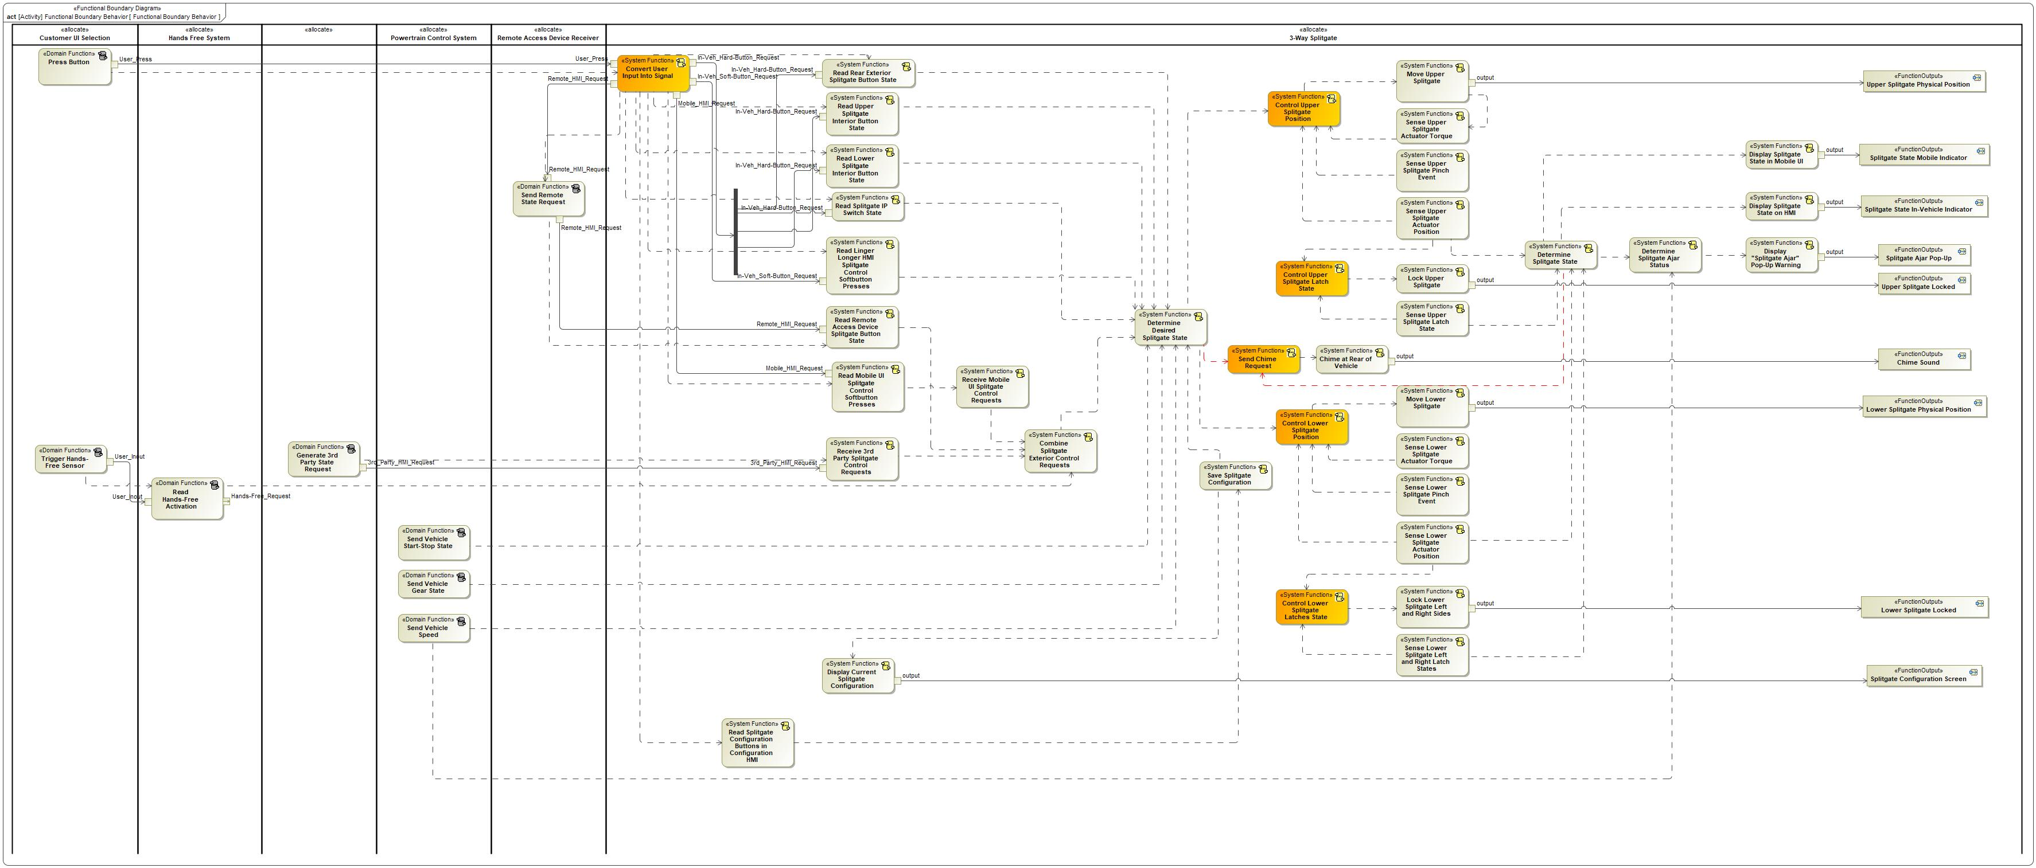

Figure 8: Functional Boundary Behavior

### List of Functions

| **Function Name** | Description | Comments |
| --- | --- | --- |
| *(activity)* Determine Desired Splitgate State |  |  |
| *(activity)* Read Hands-Free Activation |  |  |
| *(activity)* Read Mobile UI Splitgate Control Softbutton Presses |  |  |
| *(activity)* Display "Splitgate Ajar" Pop-Up Warning |  |  |
| *(activity)* Receive 3rd Party Splitgate Control Requests |  |  |
| *(activity)* Generate 3rd Party State Request |  |  |
| *(activity)* Sense Upper Splitgate Actuator Torque |  |  |
| *(activity)* Combine Splitgate Exterior Control Requests |  |  |
| *(activity)* Control Upper Splitgate Latch State |  |  |
| *(activity)* Read Linger Longer HMI Splitgate Control Softbutton Presses |  |  |
| *(activity)* Sense Upper Splitgate Latch State |  |  |
| *(activity)* Display Splitgate State in Mobile UI |  |  |
| *(activity)* Control Upper Splitgate Position |  |  |
| *(activity)* Read Lower Splitgate Interior Button State |  |  |
| *(activity)* Sense Lower Splitgate Left and Right Latch States |  |  |
| *(activity)* Sense Lower Splitgate Actuator Torque |  |  |
| *(activity)* Sense Lower Splitgate Pinch Event |  |  |
| *(activity)* Read Rear Exterior Splitgate Button State |  |  |
| *(activity)* Send Chime Request |  |  |
| *(activity)* Send Remote State Request |  |  |
| *(activity)* Trigger Hands-Free Sensor |  |  |
| *(activity)* Determine Splitgate Ajar Status |  |  |
| *(activity)* Save Splitgate Configuration |  |  |
| *(activity)* Read Upper Splitgate Interior Button State |  |  |
| *(activity)* Read Remote Access Device Splitgate Button State |  |  |
| *(activity)* Lock Lower Splitgate Left and Right Sides |  |  |
| *(activity)* Determine Splitgate State |  |  |
| *(activity)* Send Vehicle Speed |  |  |
| *(activity)* Receive Mobile UI Splitgate Control Requests |  |  |
| *(activity)* Convert User Input Into Signal |  |  |
| *(activity)* Chime at Rear of Vehicle |  |  |
| *(activity)* Move Upper Splitgate |  |  |
| *(activity)* Read Splitgate IP Switch State |  |  |
| *(activity)* Send Vehicle Gear State |  |  |
| *(activity)* Lock Upper Splitgate |  |  |
| *(activity)* Display Splitgate State on HMI |  |  |
| *(activity)* Move Lower Splitgate |  |  |
| *(activity)* Read Splitgate Configuration Buttons in Configuration HMI |  |  |
| *(activity)* Send Vehicle Start-Stop State |  |  |
| *(activity)* Control Lower Splitgate Latches State |  |  |
| *(activity)* Press Button |  |  |
| *(activity)* Sense Lower Splitgate Actuator Position |  |  |
| *(activity)* Display Current Splitgate Configuration |  |  |
| *(activity)* Sense Upper Splitgate Pinch Event |  |  |
| *(activity)* Sense Upper Splitgate Actuator Position |  |  |
| *(activity)* Control Lower Splitgate Position |  |  |

Table 16: List of Functions

## Logical Architecture

Description of diagram and content on logical architecture in Documentation field of Structural Boundary Diagram.

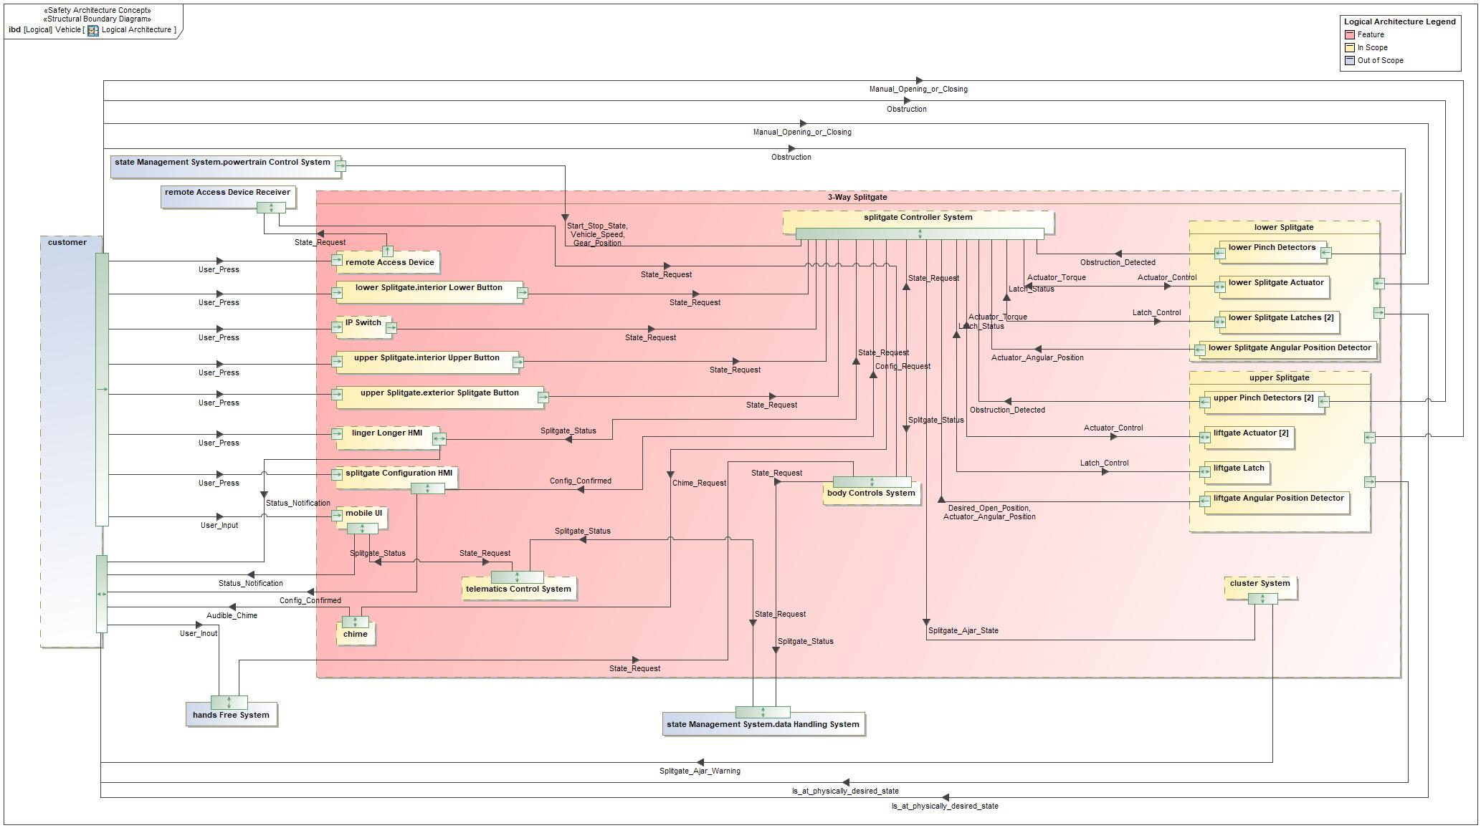

Figure 9: Logical Architecture

### Logical Elements

|  |  |  |  |
| --- | --- | --- | --- |
| **Element Name** | **Description** | **Allocated Functions** | **Comments** |
| 3-Way Splitgate | content of feature | * Chime at Rear of Vehicle * Combine Splitgate Exterior Control Requests * Control Lower Splitgate Latches State * Control Lower Splitgate Position * Control Upper Splitgate Latch State * Control Upper Splitgate Position * Convert User Input Into Signal * Determine Desired Splitgate State * Determine Splitgate Ajar Status * Determine Splitgate State * Display "Splitgate Ajar" Pop-Up Warning * Display Current Splitgate Configuration * Display Splitgate State in Mobile UI * Display Splitgate State on HMI * Lock Lower Splitgate Left and Right Sides * Lock Upper Splitgate * Move Lower Splitgate * Move Upper Splitgate * Read Linger Longer HMI Splitgate Control Softbutton Presses * Read Lower Splitgate Interior Button State * Read Mobile UI Splitgate Control Softbutton Presses * Read Rear Exterior Splitgate Button State * Read Remote Access Device Splitgate Button State * Read Splitgate Configuration Buttons in Configuration HMI * Read Splitgate IP Switch State * Read Upper Splitgate Interior Button State * Receive 3rd Party Splitgate Control Requests * Receive Mobile UI Splitgate Control Requests * Save Splitgate Configuration * Send Chime Request * Sense Lower Splitgate Actuator Position * Sense Lower Splitgate Actuator Torque * Sense Lower Splitgate Left and Right Latch States * Sense Lower Splitgate Pinch Event * Sense Upper Splitgate Actuator Position * Sense Upper Splitgate Actuator Torque * Sense Upper Splitgate Latch State * Sense Upper Splitgate Pinch Event |  |
| Body Controls System |  | * Combine Splitgate Exterior Control Requests |  |
| Chime |  | * Chime at Rear of Vehicle |  |
| Cluster System |  | * Display "Splitgate Ajar" Pop-Up Warning |  |
| Customer UI Selection |  | * Press Button * Trigger Hands-Free Sensor |  |
| Data Handling System |  |  |  |
| Exterior Splitgate Button |  | * Convert User Input Into Signal |  |
| Hands Free System |  | * Read Hands-Free Activation |  |
| Interior Lower Button |  | * Convert User Input Into Signal |  |
| Interior Upper Button |  | * Convert User Input Into Signal |  |
| IP Switch |  | * Convert User Input Into Signal |  |
| Liftgate Actuator |  | * Move Upper Splitgate * Sense Upper Splitgate Actuator Torque |  |
| Liftgate Angular Position Detector |  | * Sense Upper Splitgate Actuator Position |  |
| Liftgate Latch |  | * Lock Upper Splitgate * Sense Upper Splitgate Latch State |  |
| Linger Longer HMI |  | * Display Splitgate State on HMI * Read Linger Longer HMI Splitgate Control Softbutton Presses |  |
| Lower Pinch Detectors |  | * Sense Lower Splitgate Pinch Event |  |
| Lower Splitgate |  |  |  |
| Lower Splitgate Actuator |  | * Move Lower Splitgate * Sense Lower Splitgate Actuator Torque |  |
| Lower Splitgate Angular Position Detector |  | * Sense Lower Splitgate Actuator Position |  |
| Lower Splitgate Latches |  | * Lock Lower Splitgate Left and Right Sides * Sense Lower Splitgate Left and Right Latch States |  |
| Mobile UI |  | * Display Splitgate State in Mobile UI * Read Mobile UI Splitgate Control Softbutton Presses |  |
| Powertrain Control System |  | * Send Vehicle Gear State * Send Vehicle Speed * Send Vehicle Start-Stop State |  |
| Remote Access Device |  | * Read Remote Access Device Splitgate Button State |  |
| Remote Access Device Receiver |  | * Send Remote State Request |  |
| Splitgate Configuration HMI |  | * Display Current Splitgate Configuration * Read Splitgate Configuration Buttons in Configuration HMI |  |
| Splitgate Controller System |  | * Control Lower Splitgate Latches State * Control Lower Splitgate Position * Control Upper Splitgate Latch State * Control Upper Splitgate Position * Determine Desired Splitgate State * Determine Splitgate Ajar Status * Determine Splitgate State * Read Lower Splitgate Interior Button State * Read Rear Exterior Splitgate Button State * Read Splitgate IP Switch State * Read Upper Splitgate Interior Button State * Save Splitgate Configuration * Send Chime Request |  |
| Telematics Control System |  | * Receive 3rd Party Splitgate Control Requests * Receive Mobile UI Splitgate Control Requests |  |
| Upper Pinch Detectors |  | * Sense Upper Splitgate Pinch Event |  |
| Upper Splitgate |  |  |  |

Table 19: Logical Elements

### Logical Interfaces

|  |  |  |  |
| --- | --- | --- | --- |
| **Interface** | **Direction** | **Description** | **Value Range** |
| Actuator_Angular_Position | p1 (Liftgate Angular Position Detector) To p1 (Splitgate Controller System) |  |  |
| p2 (Lower Splitgate Angular Position Detector) To p1 (Splitgate Controller System) |  |  |
| Actuator_Control | p1 (Splitgate Controller System) To p1 (Liftgate Actuator) |  |  |
| p1 (Splitgate Controller System) To p1 (Lower Splitgate Actuator) |  |  |
| Actuator_Torque | p1 (Liftgate Actuator) To p1 (Splitgate Controller System) |  |  |
| p1 (Lower Splitgate Actuator) To p1 (Splitgate Controller System) |  |  |
| Audible_Chime | Upper Splitgate To Lower Splitgate | The description of the signal in the Documentation field. |  |
| p1 (Chime) To p2 (Customer UI Selection) | The description of the signal in the Documentation field. |  |
| Chime_Request | p1 (Splitgate Controller System) To p1 (Chime) |  |  |
| Config_Confirmed | p1 (Splitgate Controller System) To p2 (Splitgate Configuration HMI) | The description of the signal in the Documentation field. |  |
| p2 (Splitgate Configuration HMI) To p2 (Customer UI Selection) | The description of the signal in the Documentation field. |  |
| Config_Request | p2 (Splitgate Configuration HMI) To p1 (Splitgate Controller System) |  |  |
| Desired_Open_Position | p1 (Liftgate Angular Position Detector) To p1 (Splitgate Controller System) |  |  |
| Gear_Position | p1 (Powertrain Control System) To p1 (Splitgate Controller System) |  |  |
| Is_at_physically_desired_state | p1 (Lower Splitgate) To p2 (Customer UI Selection) |  |  |
| p1 (Upper Splitgate) To p2 (Customer UI Selection) |  |  |
| Latch_Control | p1 (Splitgate Controller System) To p1 (Liftgate Latch) |  |  |
| p1 (Splitgate Controller System) To p1 (Lower Splitgate Latches) |  |  |
| Latch_Status | p1 (Liftgate Latch) To p1 (Splitgate Controller System) |  |  |
| p1 (Lower Splitgate Latches) To p1 (Splitgate Controller System) |  |  |
| Manual_Opening_or_Closing | p1 (Customer UI Selection) To p2 (Lower Splitgate) |  |  |
| p1 (Customer UI Selection) To p2 (Upper Splitgate) |  |  |
| Obstruction | p1 (Customer UI Selection) To p1 (Lower Pinch Detectors) |  |  |
| p1 (Customer UI Selection) To p1 (Upper Pinch Detectors) |  |  |
| Obstruction_Detected | p2 (Lower Pinch Detectors) To p1 (Splitgate Controller System) |  |  |
| p2 (Upper Pinch Detectors) To p1 (Splitgate Controller System) |  |  |
| Splitgate_Ajar_State | p1 (Splitgate Controller System) To p1 (Cluster System) |  |  |
| Splitgate_Ajar_Warning | p1 (Cluster System) To p2 (Customer UI Selection) |  |  |
| Splitgate_Status | p1 (Body Controls System) To p2 (Data Handling System) |  |  |
| p1 (Splitgate Controller System) To p2 (Linger Longer HMI) |  |  |
| p1 (Telematics Control System) To p2 (Mobile UI) |  |  |
| p2 (Data Handling System) To p1 (Telematics Control System) |  |  |
| Start_Stop_State | p1 (Powertrain Control System) To p1 (Splitgate Controller System) |  |  |
| State_Request | p1 (Body Controls System) To p1 (Splitgate Controller System) |  |  |
| p1 (Hands Free System) To p1 (Body Controls System) |  |  |
| p1 (Remote Access Device Receiver) To p1 (Body Controls System) |  |  |
| p1 (Telematics Control System) To p2 (Data Handling System) |  |  |
| p2 (Data Handling System) To p1 (Body Controls System) |  |  |
| p2 (Exterior Splitgate Button) To p1 (Splitgate Controller System) |  |  |
| p2 (IP Switch) To p1 (Splitgate Controller System) |  |  |
| p2 (Interior Lower Button) To p1 (Splitgate Controller System) |  |  |
| p2 (Interior Upper Button) To p1 (Splitgate Controller System) |  |  |
| p2 (Linger Longer HMI) To p1 (Splitgate Controller System) |  |  |
| p2 (Mobile UI) To p1 (Telematics Control System) |  |  |
| p2 (Remote Access Device) To p1 (Remote Access Device Receiver) |  |  |
| Status_Notification | p2 (Linger Longer HMI) To p2 (Customer UI Selection) | The description of the signal in the Documentation field. |  |
| p2 (Mobile UI) To p2 (Customer UI Selection) | The description of the signal in the Documentation field. |  |
| User_Inout | p2 (Customer UI Selection) To p1 (Hands Free System) |  |  |
| User_Input | p1 (Customer UI Selection) To p1 (Mobile UI) |  |  |
| User_Press | p1 (Customer UI Selection) To p1 (Exterior Splitgate Button) |  |  |
| p1 (Customer UI Selection) To p1 (IP Switch) |  |  |
| p1 (Customer UI Selection) To p1 (Interior Lower Button) |  |  |
| p1 (Customer UI Selection) To p1 (Interior Upper Button) |  |  |
| p1 (Customer UI Selection) To p1 (Linger Longer HMI) |  |  |
| p1 (Customer UI Selection) To p1 (Remote Access Device) |  |  |
| p1 (Customer UI Selection) To p1 (Splitgate Configuration HMI) |  |  |
| Vehicle_Speed | p1 (Powertrain Control System) To p1 (Splitgate Controller System) |  |  |

Table 18: Feature Interactions

# Open Concerns

| ID | Concern Description | e-Tracker / Reference | Responsible | Status | Solution |
| --- | --- | --- | --- | --- | --- |
| 1 |  |  |  |  |  |

Table 20: Open Concerns *(Not supported by MagicDraw report generation)*

# Revision History

No Revision History found.

## Template Revisions

|  |  |  |  |  |
| --- | --- | --- | --- | --- |
| Version | Rev. | Date | Description | Responsible |
| *0* | *6* | *2015-05-26* | * *Chapter “Feature Overview” and made a 2nd level heading.* * *Chapter “Feature Modeling” divided into 3 subchapter (“Scenarios”, “Use Cases”, “State Machines”) for different modeling methods* | *Jbaden1* |
| *0* | *7* | *2015-05-27* | * *Table of Content updated* * *Template Revision History chapter added* | *Jbaden1* |
| *0* | *8* | *2015-07-02* | * *Section “Unsettled Issues” added* | *Alevin7* |
| *0* | *9* | *2015-08-04* | * *Section “Feature Variants” added* * *Section “Feature Boundary Diagram” renamed to “Feature Context Diagram”* * *Document Properties adapted to match needs of VBA macros* | *Jbaden1, Awegman1* |
| *1* | *0* | *2015-09-11* | * *Section “Feature Variants” reworked* * *Feature Goals removed. Only “Safety Goals“ chapter remains.* * *Heading 2 formatting issues corrected.* * *Requirements / Use Cases Listing removed from traceability chapter.* * *Formatting of attribute table in Notation chapter corrected* * *Open Topics / Known Issues chapter moved to the end* | *Jbaden1* |
| *1* | *1* | *2015-11-16* | * *Table-Styles removed (for smooth VSEM import)* * *Some clean-up of sections “Purpose” and “Audience”* | *Awegman1, jbaden1* |
| *1* | *2* | *2016-02-26* | * *Minor corrections based on lessons learned from CC and PCL pilot (e.g. section market/regions) and discussion with Functional Safety Team (purpose of feature)* * *Footer corrected* * *Boundary diagram interface chapter renamed to influences.* | *Jbaden1* |
| *1* | *3* | *2016-02-26* | * *Minor corrections after review with Whitney Keith from Functional Safety team* | *Jbaden1* |
| *1* | *4* | *2016-03-10* | * *Some cleanup of meta-data in Word Properties* | *Jbaden1* |
| *1* | *5* | *2016-03-10* | * *Footer formatting corrected (Issue 19)* * *Results from review with Functional Safety Team incorporated (Issue 20).* | *jbaden1* |
| *1* | *6* | *2016-04-18* | * *Scenario Template added* | *Jbaden1* |
| *1* | *7* | *2016-04-18* | * *Chapter “Operation Modes and States” moved before “Use Case” section.* | *Jbaden1* |
| *1* | *8* | *2016-04-18* | * *Broken Wiki links repaired.* | *Jbaden1* |
| *2* | *0* | *2016-05-19* | * *Adapted to Specification_Macros.dotm V2.0* * *Requirements Templates chapter (ch. 1.7.1) no longer has an attribute table, but refers directly to the Wiki..* | *Jbaden1* |
| *2* | *1* | *2016-06-10* | * *Table for Context Diagram modified (lists external entities and Influence Description only)* | *Jbaden1* |
| *2* | *2* | *2016-07-08* | * *Template version added to footer* * *Several hints added to the various sections* * *Findings from Functional Safety Team incorporated.* * *RE_SafetyRequirement style added* | *Jbaden1* |
| *2* | *3* | *2016-09-21* | * *Update from Functional Safety Team incorporated (“Lessons Learned”, “System Behaviors for HARA”)* | *Jbaden1* |
| *2* | *4* | *2016-11-15* | * *Update from Functional Safety Team incorporated (“Lessons Learned”, “System Behaviors for HARA”)* * *Explanatory notes made more formal* | *Jbaden1* |
| *3* |  |  | *Skipped to synchronize with Specification_Macros.dotm* |  |
| *4* |  |
| *5* | *0* | *2017-01-13* | * *Meta data updated for specification macros, version 3.1* * *SW Unit chapter removed for the time being* * *Green boxes added for user hints* | *Jbaden1* |
| *5* | *1* | *2017-01-18* | * *Minor editorial changes* | *Jbaden1* |
| *6* | *0* | *2017-02-03* | * *CR48: Chapter 6 renamed from “Safety” to “Functional Safety”. New sub-chapter “Safety” introduced in Non-Functional Requirements section* | *Jbaden1* |
| *6* | *0* | *2017-04-28* | * *CR7: “RequirementsTraceability” chapter removed* | *Jbaden1* |
| *6* | *0* | *2017-11-15* | * *CR32/53: New Cover Sheet + Disclaimer replaces FAP-150 like ones.* * *CR75: Some rewording -> Terminology to Glossary, Notation -> Document Conventions* * *CR49: Rename “Assumptions & Constraints” to “Assumptions”* * *CR74: Safety Assumptions added to chapter 6.* * *CR58: Add function allocation column to Logical Architecture chapter* | *Jbaden1* |
| *6* | *0* | *2018-01-31* | * *CR63: Updated links to Functional Safety Sharepoint* | *Jbaden1* |
| *6* | *0* | *2018-07-24* | * *CR69: Add FSR to FeatureDoc* * *CR64: Add new section "Design Requirements" to Function Spec and Feature Spec* | *Jbaden1* |
| *6* | *0* | *2018-08-06* | * *CR53: some corrections for metada and formatting* | *Jbaden1* |
| *6* | *0* | *2018-09-28* | * *Broken links to RE Wiki repaired* | *Jbaden1* |
| *6* | *0* | *2018-10-31* | * *Cover sheet and footer more GIS like. Functional Safety team feedback incorporated:*   + *New subsections “Functional Safety Requirements, (Decomposed) FSRs and Parameters / Values*   + *Removal of “Logical Architecture”* | *Jbaden1* |
| *6* | *0* | *2018-12-12* | * *FSR template removed, now as a macro in the Specification_Macros.dotm* | *Jbaden1* |
| *N* |  | *2019-04-03* | * *Updated code for context diagrams, actors and use cases.* * *Updated code structure with all macros at the beginning.* * *Updated code to populate assumptions using element-assumption relationship or hazardous event.* | *snuesch* |
| *N* |  | *2019-04-18* | * *Added structural boundary diagram for FuSa based on TGB discussion.* * *Added operating modes to functional safety requirements.* | *snuesch* |
| *N* |  | *2019-04-25* | * *Improved export of actions and activities on functional boundary diagram.* | *snuesch* |
| *6* | *0b* | *2019-05-23* | * *Re-introduce “Logical Architecture” (for Functional Safety)* | *Jbaden1* |
| *N* |  | *2019-06-17* | * *Aligned “Architecture” section with RE template.* * *Made “Ford Documents” table more flexible.* * *Added template terms to glossary* | *snuesch* |
| *N* |  | *2019-06-25* | * *Improved use cases to handle Primary and Secondary actors.* * *Added Performance Requirements to Uncategorized.* | *snuesch* |
| *6* | *0b* | *2019-06-26* | * *Chapter “Logical Elements” in “Logical Architecture” section added (FuSa CR 15136240)* * *“References” and “Glossary” chapter moved from section “Feature Overview” to “Introduction”. References and Glossary should be available in the document as early as possible* | *Jbaden1* |
| *N* |  | *2019-07-25* | * *Added populated “Logical Elements” table and allocated functions.* * *Export documentation field of context diagram.* | *snuesch* |
| *N* |  | *2019-08-09* | * *Export documentation field of use case diagram.* * *Fixed bug in Feature Requirement Verification Method.* * *Simplified export of References without publisher.* | *snuesch* |
| *N* |  | *2019-08-21* | * *Improved glossary and acronym tables* | *snuesch* |
| *N* |  | *2019-08-28* | * *Fixed bug in populating title in header* | *snuesch* |
| *N* |  | *2019-09-16* | * *Updated bibliography export* | *snuesch* |
| *N* |  | *2019-09-27* | * *Updated export of Verification Method and Requirement Status for Feature Requirements and V&V Method for Functional Safety Requirements.* | *snuesch* |

# Appendix

## Definitions

| **Definition** | **Description** |
| --- | --- |
| High speed | Approximately more than 52 mph (83 kph) |
| Low speed | Approximately 12 to 36 mph (19 to 58 kph ) |
| Medium speed | Approximately 36 mph to 52 mph (58 to 83 kph) |
| term | A representation of a Concept expressed in Natural Language. In the vocabulary of a Domain of Discourse a term enables common understanding of domain concepts. |
| term glossary | A term glossary is a table of agreed upon definitions for terms used in project development that may provide clarity or avoid confusion to stakeholders. |
| TLA | Three Letter Acronym |
| Very Low Speed | Approximately 0 to 12 mph (0 to 19 kph) |

Table 21: Definitions used in this document

## Abbreviations

| **Abbr.** | **Stands for** |
| --- | --- |
| ATLA | Another Three Letter Acronym |

Table 22: Abbreviations used in this document

Document ends here.